POSITION TITLE
Marketing Manager
DEPARTMENT
Office of Student Life and Veteran Services Office
POSITION CATEGORY
Student Intern
JOB SUMMARY
The Marketing Manager serves as the Student Veterans of America (SVA) Chapter Secretary. Responsible for capturing images of all SVA Chapter events for social media accounts. Manages all internal and external communications of the SVA Chapter. Reports social media account metrics and develops campaigns to represent the chapter, the college, and all military-affiliated college students in a positive light. Serves as the subject matter expert relating to CCRI’s Student Life Policies & Procedures for student-led organizations. The Marketing Manager should have a strong business-mind and entrepreneurial nature.
DUTIES AND RESPONSIBILITES
- Schedules and produces content daily to the SVA Chapter social media accounts.
- Writes emails and correspondence to chapter members.
- Maintains accurate membership contact rosters.
- Designs digital and print media promoting the SVA Chapter and posts on campus.
- Attends all student government meetings as the senior SVA representative.
- Participates in the annual SVA Leadership Summit on behalf of all CCRI students.
- Liaises with SVA Chapter leaders at Bristol Community College, Bryant University, Brown University, New England Tech, Rhode Island College, and the University of Rhode Island.
- Ensures the SVA Chapter complies with all regulations set by the college.
- Adheres to brand usage and marketing policies of CCRI and SVA National Headquarters.
- Liaises with the CCRI Marketing Department.
- Communicates regularly with SVA National Headquarters.
- Recruits and trains the next Marketing Manager.
MINIMUM QUALIFICATIONS
- One (1) academic year remaining at CCRI.
- Completion of Principles of Marketing (BUSN 2060) or Marketing Communications (BUSN 2061) with a “B” of higher.
- 2.5 cumulative GPA or higher.

PREFFERRED QUALIFICATIONS
- Pursing a degree in Marketing, Communications, or any business program.
- Be a 3/4 full-time student using a GI Bill benefit to pay for school.
REPORTS TO
Reports directly to the CCRI Veteran Resource Coordinator. Fully supports the SVA Chapter President. Liaises closely with the CCRI Student Government and
VACANCIES, LOCATION, AND SCHEDULE
One (1) position available. Can work remotely. Flexible schedule up to 25 hours per week.
WORK SCHEDULE
Schedule is flexible around academic, professional, and personal schedules. Minimum five (5) hours per week with a maximum allowable of 25 hours per week. Must attend weekly team meetings (virtual) for the SVA Chapter executive board and CCRI Student Government sessions.
FULL TIME/PART TIME
Part time.
PERMANENT/LIMITED POSITION
Limited. As available.
BENEFITS
None.
PAY
Pay available to those eligible for VA Work Study. Must be ¾ full-time AND be using a GI Bill benefit to be eligible for pay. Otherwise, available for academic credit or Honors Program projects depending on professor approval.
ADDITIONAL SALARY INFROMATION
Pay is tax free if eligible for VA Work Study. Amount is federal or state minimum wage, whichever is more.
LENGTH OF CONTRACT
VA Work Study contracts are for one (1) academic semester. The position is itself does not have a limit.
NUMBER OF VACANCIES
One position available.
APPLICATION OPEN DATE
Position opens 45 days before the start of the academic semester.
APPLICATION CLOSE DATE
Until filled.
REQUIRED DOCUMENTS
- Unofficial transcript
- Resume*
- Cover Letter*
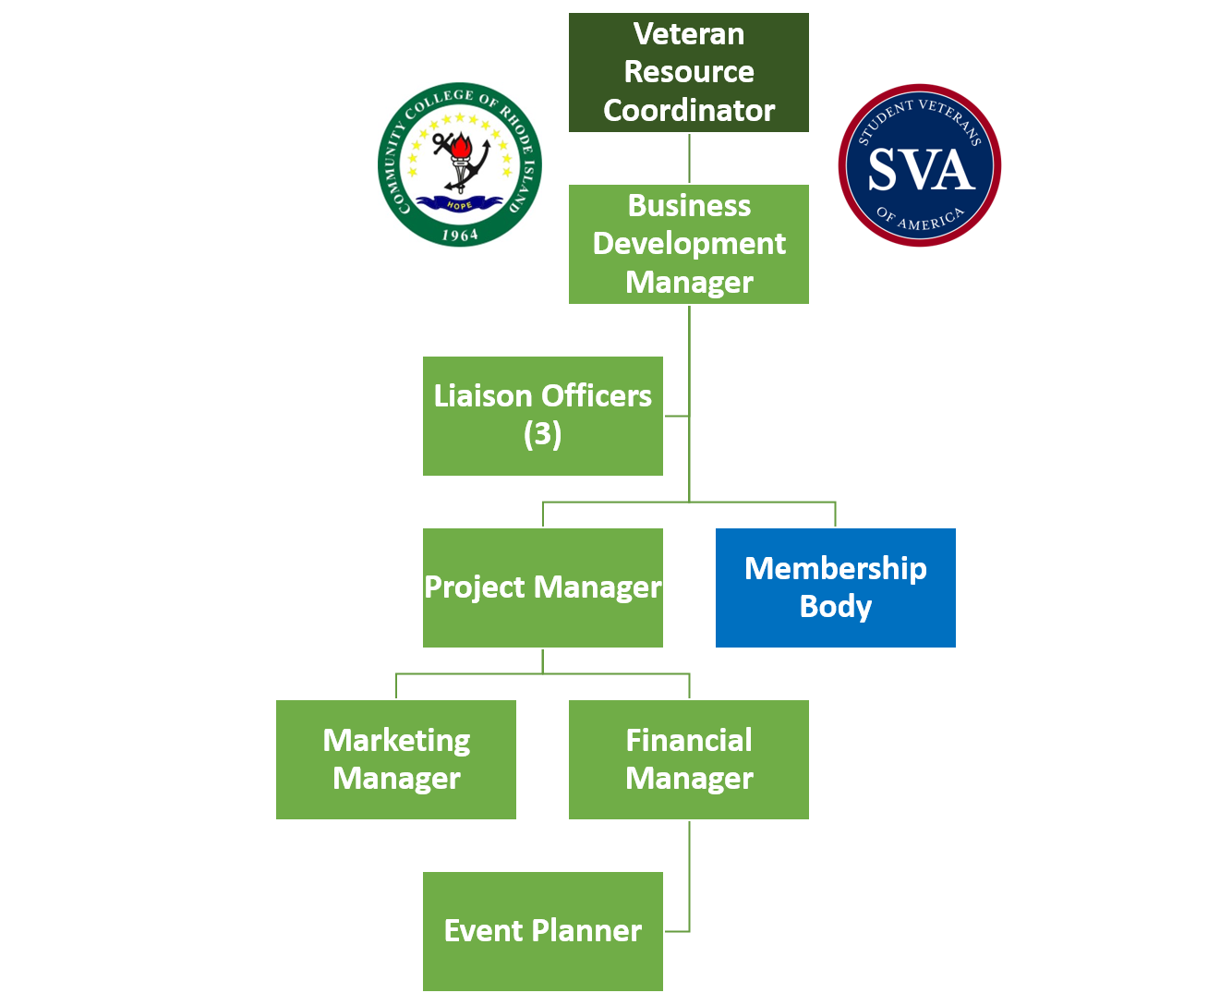
*Ensure documents are tailored specifically to this position. Schedule an appointment with Career Services for guidance.

