POSITION TITLE
Financial Manager
DEPARTMENT
Office of Student Life and Veteran Services Office
POSITION CATEGORY
Student Intern
JOB SUMMARY
The Financial Manager serves as the Student Veterans of America (SVA) Chapter Treasurer. Responsible for all the planning, budgeting, accounting, for the chapter. Advises the SVA Chapter President on all financial matters. Liaises with CCRI Student Government Treasurer. Serves as the subject matter expert relating to CCRI’s Student Life Policies & Procedures for student-led organizations. Prepares and submits timely budget requests to Student Government. Plans and leads fundraiser activities on behalf of the SVA Chapter. Deposits all funds in accordance with policies and procedures. The Financial Manager should have a strong business-mind and entrepreneurial nature.
DUTIES AND RESPONSIBILITES
- Advises the SVA Chapter President on the financial standing of the chapter.
- Prepares budget requests and submits them to CCRI’ Student Government.
- Maintains accurate balance sheets, income statements, and cash flow statements.
- Attends student government and student senate meetings as an SVA representative.
- Develops rapport and a strong working relationship with the Treasurer of CCRI student government.
- Participates in the annual SVA Leadership Summit on behalf of all CCRI students.
- Liaises with SVA Chapter Treasurers at Bristol Community College, Bryant University, Brown University, New England Tech, Rhode Island College, and the University of Rhode Island.
- Seeks vendors and prepares purchase orders in accordance with Policies and Procedures from CCRI’s Office of Student Life.
- Files receipts, bills, invoices, and financial reports into the Treasurer’s Continuity Binder.
- Plans and develops fund raiser strategies for the SVA Chapter.
- Develops and maintains a list of donors and alumni.
- Deposits funds into the SVA Chapter account in accordance with Policies and Procedures from CCRI’s Office of Student Life.
- Ensures the SVA Chapter complies with all financial regulations set by the college.
- Recruits and trains the next Financial Manager.

MINIMUM QUALIFICATIONS
- One (1) academic year remaining at CCRI.
- Completed Financial Accounting (ACCT 1010) with a grade of “B” or higher.
- 2.5 cumulative GPA or higher.
PREFFERRED QUALIFICATIONS
- Pursing a degree in Accounting, Financial Services, or any business program.
- Be a 3/4 full-time student using a GI Bill benefit to pay for school.
REPORTS TO
Reports directly to the CCRI Veteran Resource Coordinator and fully supports the SVA Chapter President. Liaises closely with the Treasurer of the CCRI Student Government.
VACANCIES, LOCATION, AND SCHEDULE
One (1) position available. Can work remotely. Flexible schedule up to 25 hours per week.
WORK SCHEDULE
Schedule is flexible around academic, professional, and personal schedules. Minimum five (5) hours per week with a maximum allowable of 25 hours per week. Must attend weekly team meetings (virtual) for the SVA Chapter executive board and CCRI Student Government sessions.
FULL TIME/PART TIME
Part time.
PERMANENT/LIMITED POSITION
Limited. As available.
BENEFITS
None.
PAY
Pay available to those eligible for VA Work Study. Must be ¾ full-time AND be using a GI Bill benefit to be eligible for pay. Otherwise, available for academic credit or Honors Program projects depending on professor approval.
ADDITIONAL SALARY INFROMATION
Pay is tax free if eligible for VA Work Study. Amount is federal or state minimum wage, whichever is more.

LENGTH OF CONTRACT
VA Work Study contracts are for one (1) academic semester. The position is itself does not have a limit.
NUMBER OF VACANCIES
One position available.
APPLICATION OPEN DATE
Position opens 45 days before the start of the academic semester.
APPLICATION CLOSE DATE
Until filled.
REQUIRED DOCUMENTS
- Unofficial transcript
- Resume*
- Cover Letter*
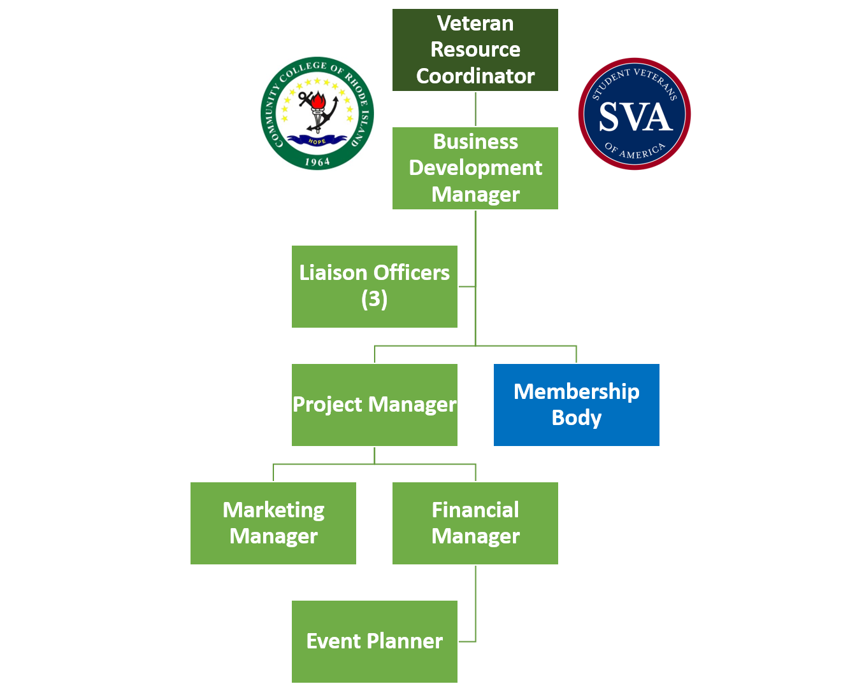
*Ensure documents are tailored specifically to this position. Schedule an appointment with Career Services for guidance.

