POSITION TITLE
Event Planner
DEPARTMENT
Office of Student Life and Veteran Services Office
POSITION CATEGORY
Student Intern
JOB SUMMARY
The Event Planner serves as an aide to the Student Veterans of America (SVA) Chapter Treasurer. Responsible for all the planning, coordination, budgeting, scheduling, and execution of SVA Chapter meetings, executive leadership meetings, signature events, and virtual meetings. Liaises with CCRI Office of Student Life for resources and space reservations. Serves as the subject matter expert relating to CCRI’s Student Life Policies & Procedures for student-led organizations. Assesses and prepares budgets with the Treasurer given the President’s strategic plan and agenda for the semester. Plans and leads fundraiser activities on behalf of the SVA Chapter. Deposits all funds in accordance with policies and procedures. The Event Planner Manager should have a strong business-mind and entrepreneurial nature.
DUTIES AND RESPONSIBILITES
- Works with the SVA Chapter Treasurer.
- Sets up and breaks down chapter meeting spaces and events.
- Analyses the President’s strategic plan and agenda to develop an accurate budget request.
- Maintains the chapter’s long and short term calendar of events.
- Coordinates the chapter, college, and SVA National calendar of events.
- Attends student government and student senate meetings as an SVA representative.
- Develops rapport and a strong working relationship with the CCRI Student Life Coordinators.
- Reserves physical space on campus for chapter meetings and events.
- Hosts the chapter virtual meeting technology platform.
- Participates in the annual SVA Leadership Summit on behalf of all CCRI students.
- Works with the SVA Chapter Secretary to promote all chapter events.
- Seeks vendors and prepares purchase orders in accordance with Policies and Procedures from CCRI’s Office of Student Life.
- Files receipts, bills, invoices, and financial reports into the Treasurer’s Continuity Binder.
- Plans and develops fund raiser strategies for the SVA Chapter.
- Develops and maintains a list of donors and alumni.
- Ensures the SVA Chapter complies with all financial regulations set by the college.
- Recruits and trains the next Event Planner.

MINIMUM QUALIFICATIONS
- One (1) academic year remaining at CCRI.
- 2.5 cumulative GPA or higher.
PREFFERRED QUALIFICATIONS
- Pursing a degree in Marketing, Communications, or any business program.
- Completed Financial Accounting (ACCT 1010) with a grade of “B” or higher.
- Be a 3/4 full-time student using a GI Bill benefit to pay for school.
REPORTS TO
Reports directly to the CCRI Veteran Resource Coordinator and fully supports the SVA Chapter Treasurer. Liaises closely with the Treasurer of the CCRI Student Life Coordinators and Marketing Department.
VACANCIES, LOCATION, AND SCHEDULE
One (1) position available. Can work remotely. Flexible schedule up to 25 hours per week.
WORK SCHEDULE
Schedule is flexible around academic, professional, and personal schedules. Minimum five (5) hours per week with a maximum allowable of 25 hours per week. Must attend weekly team meetings (virtual) for the SVA Chapter executive board and CCRI Student Government sessions.
FULL TIME/PART TIME
Part time.
PERMANENT/LIMITED POSITION
Limited. As available.
BENEFITS
None.
PAY
Pay available to those eligible for VA Work Study. Must be ¾ full-time AND be using a GI Bill benefit to be eligible for pay. Otherwise, available for academic credit or Honors Program projects depending on professor approval.
ADDITIONAL SALARY INFROMATION
Pay is tax free if eligible for VA Work Study. Amount is federal or state minimum wage, whichever is more.
LENGTH OF CONTRACT
VA Work Study contracts are for one (1) academic semester. The position is itself does not have a limit.
NUMBER OF VACANCIES
One position available.
APPLICATION OPEN DATE
Position opens 45 days before the start of the academic semester.
APPLICATION CLOSE DATE
Until filled.
REQUIRED DOCUMENTS
- Unofficial transcript
- Resume*
- Cover Letter*
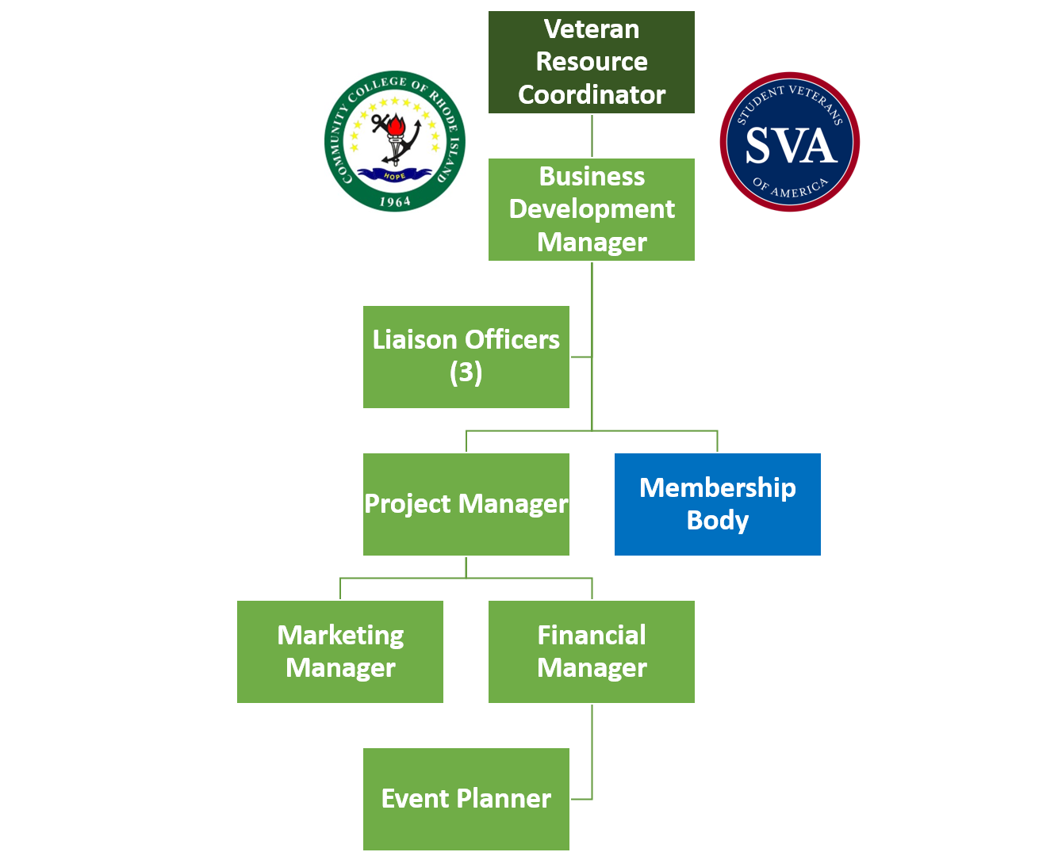
*Ensure documents are tailored specifically to this position. Schedule an appointment with Career Services for guidance.

