POSITION TITLE
Business Development Manager
DEPARTMENT
Office of Student Life and Veteran Services Office
POSITION CATEGORY
Student Intern
JOB SUMMARY
The Business Development Manager serves as the Student Veterans of America (SVA) Chapter President. Responsible for developing the strategic plan of the chapter in order to create value for members and the community. Primary focus on recruiting enrolled students into the chapter as active members and developing veteran-centered programming. Also serves as the voice for all military-affiliated students at CCRI. Works with the Financial Manager to develop revenue streams and profit centers for the chapter as a 501(c)3 educational organization. Liaises with CCRI Student Government President. Serves as the subject matter expert relating to CCRI’s Student Life Policies & Procedures for student-led organizations. The Business Development Manager should have a strong business-mind and entrepreneurial nature.
DUTIES AND RESPONSIBILITES
- Overall responsible for what the SVA Chapter does or fails to do.
- Develops the SVA Chapter’s long term strategic plan and sets the agenda.
- Focuses on creating value for all members.
- Attends all student government meetings as the senior SVA representative.
- Develops rapport and a strong working relationship with the President of CCRI student government.
- Participates in the annual SVA Leadership Summit on behalf of all CCRI students.
- Liaises with SVA Chapter Presidents at Bristol Community College, Bryant University, Brown University, New England Tech, Rhode Island College, and the University of Rhode Island.
- Plans and develops fund raiser strategies for the SVA Chapter with the Financial Manager.
- Ensures the SVA Chapter complies with all regulations set by the college.
- Sets goals for membership recruitment.
- Partners with national, regional, state, and local veteran service organizations.
- Communicates regularly with SVA National Headquarters.
- Recruits and trains the next Business Development Manager.

MINIMUM QUALIFICATIONS
- One (1) academic year remaining at CCRI.
- 2.5 cumulative GPA or higher.
PREFFERRED QUALIFICATIONS
- Pursing a degree in Business Management, General Business, Communication, or any business program.
- Be a 3/4 full-time student using a GI Bill benefit to pay for school.
REPORTS TO
Reports directly to the CCRI Veteran Resource Coordinator. Liaises closely with the President of the CCRI Student Government.
VACANCIES, LOCATION, AND SCHEDULE
One (1) position available. Can work remotely. Flexible schedule up to 25 hours per week.
WORK SCHEDULE
Schedule is flexible around academic, professional, and personal schedules. Minimum five (5) hours per week with a maximum allowable of 25 hours per week. Must attend weekly team meetings (virtual) for the SVA Chapter executive board and CCRI Student Government sessions.
FULL TIME/PART TIME
Part time.
PERMANENT/LIMITED POSITION
Limited. As available.
BENEFITS
None.
PAY
Pay available to those eligible for VA Work Study. Must be ¾ full-time AND be using a GI Bill benefit to be eligible for pay. Otherwise, available for academic credit or Honors Program projects depending on professor approval.
ADDITIONAL SALARY INFROMATION
Pay is tax free if eligible for VA Work Study. Amount is federal or state minimum wage, whichever is more.

LENGTH OF CONTRACT
VA Work Study contracts are for one (1) academic semester. The position is itself does not have a limit.
NUMBER OF VACANCIES
One position available.
APPLICATION OPEN DATE
Position opens 45 days before the start of the academic semester.
APPLICATION CLOSE DATE
Until filled.
REQUIRED DOCUMENTS
- Unofficial transcript
- Resume*
- Cover Letter*
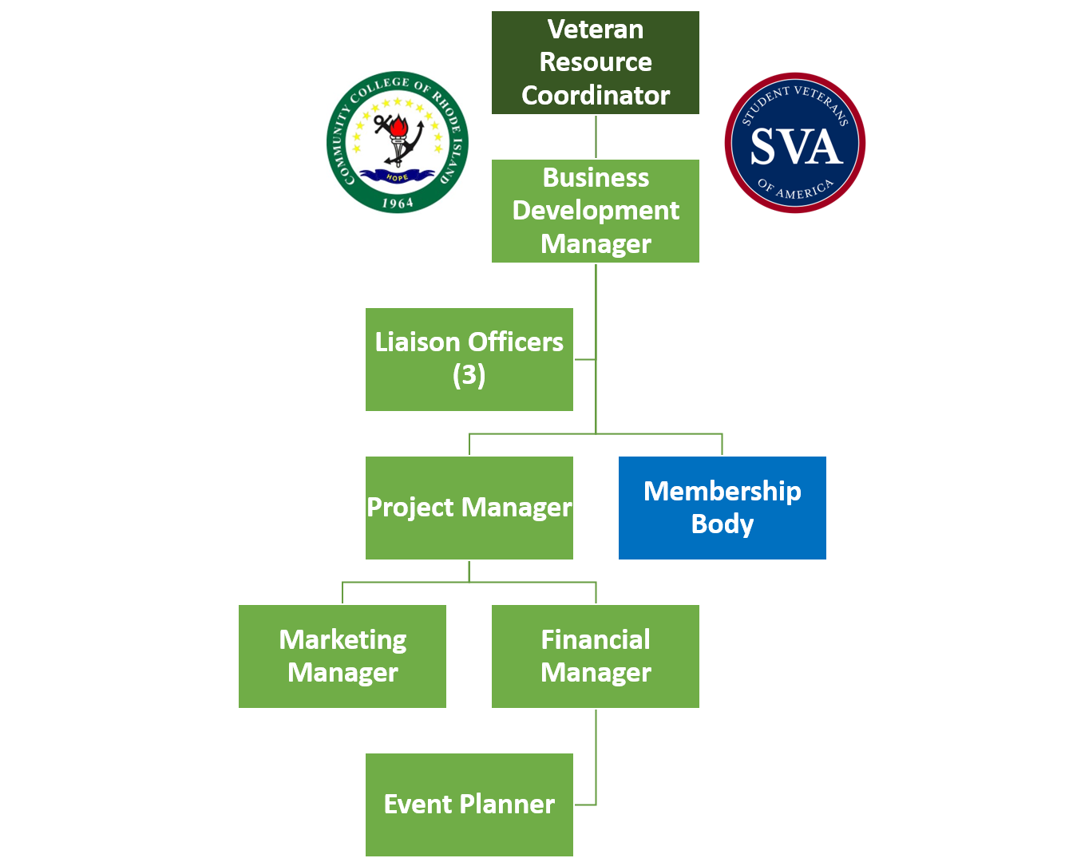
*Ensure documents are tailored specifically to this position. Schedule an appointment with Career Services for guidance.

