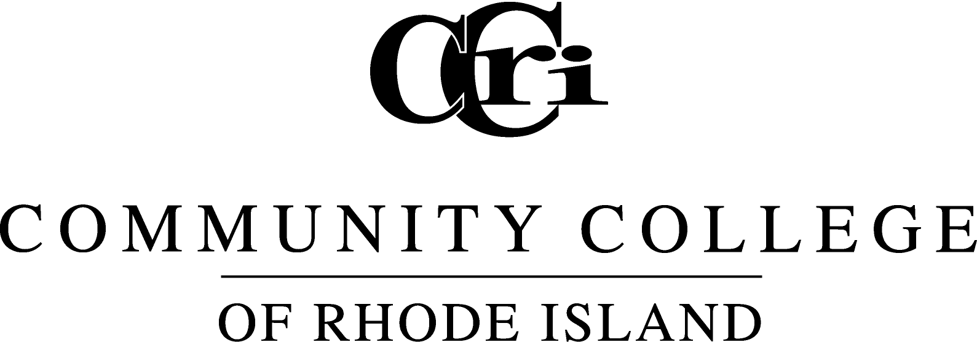
Commencement address by CCRI President Ray Di Pasquale
May 16, 2014

Governor Chafee, Senator Reed, Congressman Cicilline, Chairwoman Mancuso and members of the Board of Education, city and state officials, our student speaker Chad McFarlane, CCRI faculty, staff and alumni, guests, and friends of the college … thank you all for being such an important part of this extraordinary day to celebrate the Class of 2014!

Commencement is a time for joy and reflection. As we close the book on our 49th academic year, we realize that time is ever moving. The college is moving on toward a very special occasion; when classes begin in September, we will be celebrating our 50th anniversary and we have a special year planned. Likewise, you will all move on to the next step in your own journey – that may be a job, it may be to another school, it may be to tend to your family. But you will move on uniquely prepared to face your new challenges.

Take pride in the fact that you are now part of more than 62,000 CCRI alumni. This college has done a remarkable job preparing its students for the challenges that lie ahead. As graduates of the Community College of Rhode Island, hold your heads high. You have reason to be proud.

Our Nursing program was reaccredited this year, and in my opinion and the opinion of many others, CCRI nurses are the best in the state! Go into any dentist’s office and, chances are, the dental hygienist working on you is a CCRI grad. Our music program is accredited and turning out amazingly talented musicians, and our Art Department is on its way to accreditation and soon will have renovated studios.

Manufacturing is taking on renewed importance in our state and our engineering and technology students are taking advantage of our new, state-of-the-art equipment. Our General Studies graduates have immersed themselves in the arts and sciences and are well-rounded students who are ready to continue their education elsewhere or take on meaningful jobs. I could go on and on. Be proud of your degree! It will serve you well.

As we reflect, it’s important to realize that none of us achieves a moment like this alone. We all have someone who played a major part in helping us arrive here. It might be a faculty member who inspired you, a staff member who advised you or a family member or friend who supported you.

I would like all of our graduates to please stand and to recognize the people who have helped them along this journey. To the parents, spouses, children, siblings, grandparents, friends and all other relatives; to the faculty, staff and administration – thank you for being here today to support the members of the Class of 2014. Please give them a hand!

As college graduates, we take on new responsibilities. We realize that others helped us to get here today, and it’s only right that we pay that forward. In these difficult economic times, we all know someone who is struggling and has no idea what steps to take or where to turn. I want all of you to take a second and think of someone in your life who could use your help and support.

Reach out to him or her with words of encouragement and advice and share how education has changed your life. Education is the key to unlocking Rhode Island’s economic solutions, and whether it’s here at CCRI or elsewhere, continuing education is a critical first step.

Your educational journey has brought you here to this moment. You have begun to change your lives and achieve your dreams. I am so proud of you. We are all proud of you.

Michael Gelb, an author and public speaker specializing in creativity and innovation, said, “Life is a continuous exercise in creative problem solving.” It can also be said that your experiences at CCRI have taught you the critical thinking necessary to solve problems, whether in your professions, in your future education or in your personal lives.

We know you will continue to make us proud by overcoming the challenges that you face. Class of 2014, there is so much for you to do, and the world is ready for you! Congratulations on joining the ranks of more than 62,000 alumni from New England’s largest community college. Give yourselves a round of applause for all that you have accomplished at CCRI!

Tonight, as we do every year, we want to share with you the stories of some of your fellow graduates. All were candidates for student commencement speaker, and any one of them could have represented your class wonderfully here today.

Just like all of you, they have persevered through many challenges to complete their degrees.

Aubrey Fletcher took a break from college to work for a while and was an employee at Sam’s Club in Warwick when the store closed in 2011 for renovations. His wife and her grandmother sat him down and told him it was time to pursue his interest in computers – that it was time to go back to school. He is graduating tonight with a degree in Computer Programming with a 3.53 GPA and as a member of Phi Theta Kappa. He hopes to serve as an inspiration to his nearly 1-year-old daughter, Giselle. Aubrey, we’re sure she will be very proud of your accomplishments!

Nida Islam emigrated from Pakistan when she was 10 years old. As she grew up here in America, she saw that she could go beyond her cultural and religious norms, where women are expected to stay home to raise a family. She realized she could pursue her dreams of education and a career, and tonight she is graduating with a degree in General Studies as a member of Phi Theta Kappa and Psi Beta honor societies and as an Honors Program graduate. She has maintained an impressive 3.94 GPA despite working two jobs while she was a student. She will continue on to attain her bachelor’s degree and wants to pursue a career in writing or publishing. We are so glad you chose to start your educational journey at CCRI, Nida!

Tiffany Rezendes began her pursuit of higher education at Rhode Island College but came to CCRI after her first year to take some of her general education requirements at a lower cost. Well, she fell in love with CCRI and decided to stay until she graduated! Tonight she will receive her Liberal Arts degree with a concentration in psychology and she is graduating with a 3.82 GPA. During her time here she worked as a peer tutor, helping students studying psychology and has participated in DECA and the Bible Study Club. She is very involved in her church’s youth ministry and is considering pursuing a degree in theology after graduation. Congratulations, Tiffany!

Now you can see what a difficult choice our committee had! I assure you that all of our nominees were as impressive as these three finalists. Congratulations to all of you!

And now, I’m pleased to introduce you to your Class of 2014 student commencement speaker, Chad McFarlane.

Chad has overcome many obstacles to be where he is today. He grew up in Connecticut and Florida, but came to Rhode Island after struggling to find a place of his own during his high school years. He had lived in his car for five months before moving in with his sister in Providence, completing high school through the Providence Alternative Diploma Program. After 9/11, he joined the U.S. Army and completed two tours in Iraq as a tank gunner. Following his discharge, he worked as a mail carrier in Florida before moving back to Rhode Island to come to CCRI.

Here, he has been a tireless advocate for our student-veterans, serving as president of the CCRI Student Veterans Organization and also on the board of directors of the Rhode Island Military Organization, which recently established a military lounge at T.F. Green Airport and works on other issues supporting the state’s military families.

He was named a 2013 Newman Civic Fellow by Campus Compact and he is one of 20 members of this year’s New Leaders Council of Rhode Island. He is graduating tonight with a degree in General Studies and will transfer to a four-year institution to pursue a degree in electrical engineering.

We are so proud of what he has accomplished since he arrived at CCRI. Please help me welcome your student speaker, Chad McFarlane!

###

