German Castle Legends of the
Upper Middle Rhine
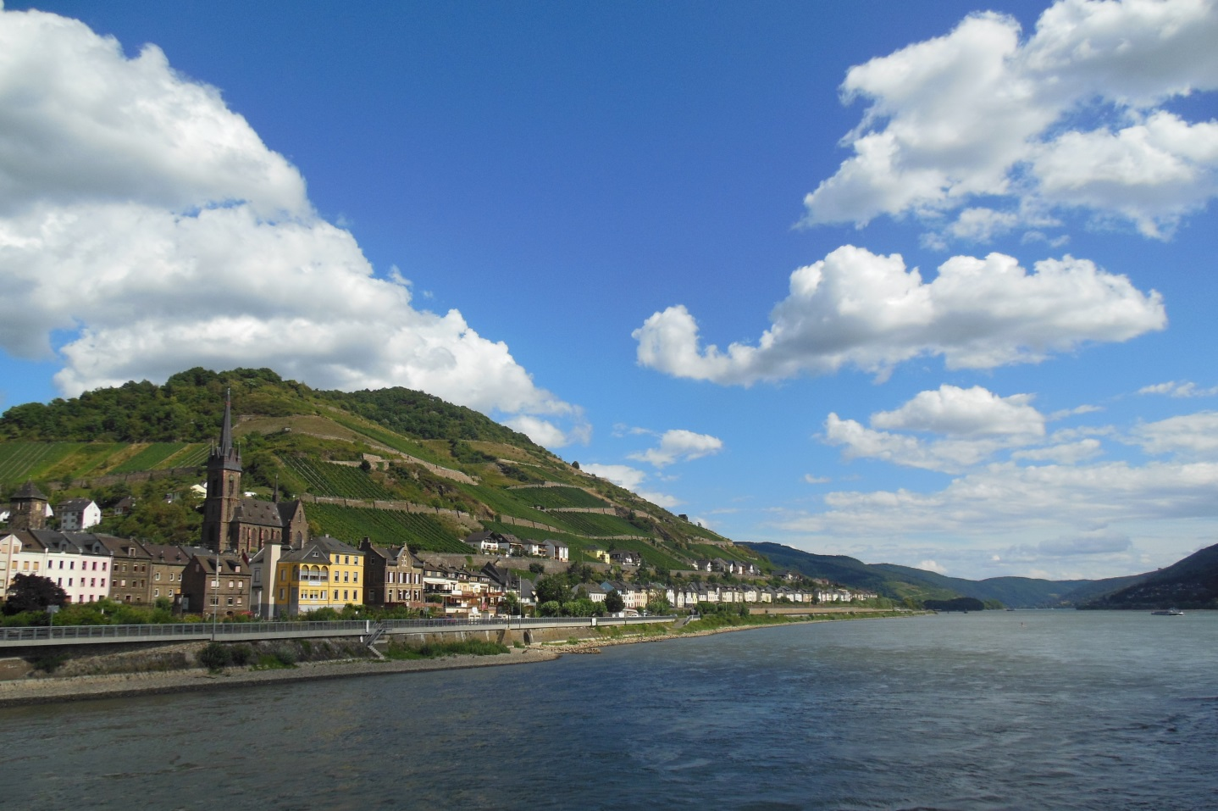

Katja J. Dodge
December 12, 2013
German 1010
Frau Panaccione
Table of Contents
Introduction to Legend 3
Introduction to Father Rhine 5
The Upper Middle Rhine 5
Upper Middle Rhine Castles 6
Sterrenberg und Liebenstein 10
A Brief History 10
The Hostile Brothers 11
Burg Rheinfels 13
A Brief History 13
The Linden Tree 14
Schönburg 16
A Brief History 16
The Seven Sisters 17
Pfalzgrafenstein 19
A Brief History 19
The Palatinate 20
Burg Sooneck 22
A Brief History 22
The Blind Archer 23
Burg Reichenstein 25
A Brief History 25
The Headless Ghost 26
Burg Rheinstein 28
A Brief History 28
The Wooing 29
Der Maus Turm 32
A Brief History 32
The Story of Bishop Hatto 33
Works Cited 35

Introduction to Legend
When considering legends, it is important to recognize several factors which define what makes a legend in the first place. Often legends can become confused with myths and fables; they have different characteristics, making them singularly unique, but also vary slightly.
A myth is among the oldest stories told. They generally involve supernatural powers and activity, and were meant to explain the universe and nature in a time long before science. Many religions are based in myth as a way to share God’s creation of earth and miracles thereafter, such as Jesus or Adam and Eve.
A fable is a story designed to convey a moral lesson. As a rule, they tend to involve animals, plants, nature and objects, giving them life-like and humanistic personalities and capabilities. The stories are short and concise, so they are easily understood by all ages. Although largely passed from generation orally, many have been written down and found in different literature around the world.
A legend is also most often passed along via the spoken word. They are stories based on real people, actions or events, but because they have been told so many times the original tale becomes lost and exaggerated in people’s imaginations. Once literacy became more common among the classes and people started writing the stories down, the embellishments and exaggerations became much more evident.
So why, if these stories are possibly more fiction than fact, are people still telling them to this day, in a world of information and science? The answer is actually quite simple. The cultures birthing these tales are so ancient – from the dark ages and on – that they have no written record or documentation of their histories. As Americans, it may be hard for us to grasp this notion. Our nation is very young; from the moment the “new world” was discovered, people were writing down every detail and every account. Nothing in our country’s past is left to definite mystery, we had no Dark Age or Middle Age where entire empires rose and fell before us, where record and evidence were lost forever to time and advancement and chaos.
So what do you do when you are in a land so old nobody is certain where it even came from? When documented factual evidence is lacking and you only have bits of stories from your forefather’s to rely on? Whether or not they are embellished, the legends shared about people and events before their time have to be taken at their word. In this tradition, and in this way, legend has become history.
This exaggerated history, which is lovingly embraced by the culture surrounding it, has by now been written and recorded several times, and often with several versions. However, never are they so varied that they do not convey the same type of moral message or lesson to be learned, which is much like a fable. This is the true value of a legend. It exists to teach – much like history – so mistakes of the past are not repeated.
The time of historical legends is now long behind us. In our modern world, events are known to everyone as they happen, and tediously documented for future generations, a practice which has been picking up momentum since the end of the Middle Ages in the 15th century. Today, a legend is used to describe someone extremely successful in their endeavors that will likely be revered and remembered for generations, such as the famous baseball player Babe Ruth.

Introduction to Father Rhine
All of Europe is surrounded in legend. Evidence of people living there dates back to thousands of years before Christ. Indeed, it is an area where many parts of its ancient history as fact are left to question. Modern day Germany is no exception in this, and one area in particular which is famous for its legends are along the banks the Rhine River.
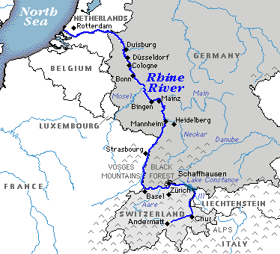
The Rhine runs 765 miles north from the Alps of Switzerland to the North Sea of the Netherlands (Figure A). Its waters flow through several countries from start to finish, but the bulk of it runs through Germany, making the Rhine unquestionably German. From the time of the Romans, this river has been a critical vessel of expansion and trade. The empire utilized this river in its conquest north in attempt to acquire lands and resources while spreading their ideals for civilization. This was no easy endeavor due to many clashes with local barbaric tribes and the treacherous nature of the river landscape. Although the Roman Empire did eventually fall, its impact on the region was never lost, and many original Roman towns and cities still exist today along the Rhine in Germany.
A
The popularity of the Rhine did not end with the Romans. Many tribes and empires would vie for rights to its waters and abundant shores for centuries. The river was a central vessel for religious pilgrimage and agriculture, as the Romans clearly demonstrated; to have power over the Rhine was to have wealth and opportunity.
The Upper Middle Rhine
The Rhine River is divided into segments, based on the geography. They are listed as follows, beginning at the river’s source: the Alpine Rhine, the High Rhine, the Upper Rhine, the Upper Middle Rhine, the Middle Rhine, the Lower Rhine and the Rhine Delta. Nowhere along the Rhine was so splendid for agriculture - specifically that of wine making - as the Upper Middle Rhine. Here, between the modern cities of Koblenz and Mainz, the river cuts between slate mountains, narrowing and winding through steep cliffs exposed to southern light and shielded from the harshest of weather, ideal to produce the quality of grape required to make wine.
Wine was a necessity for ancient civilization since water was frequently contaminated and unsafe for human consumption. Because the distilling process killed potential bacteria, wine was essential for survival. In fact, it is known Roman soldiers were required to drink wine every day in order to stay healthy.
As people began expanding and settling to farm or work on the river, a greater need was expressed for those in power to protect and defend the lands and townships surrounding the vineyards. As a result, different areas of nobility and royalty began building castles and forts to guard their interests along the Upper Middle Rhine.
Upper Middle Rhine Castles
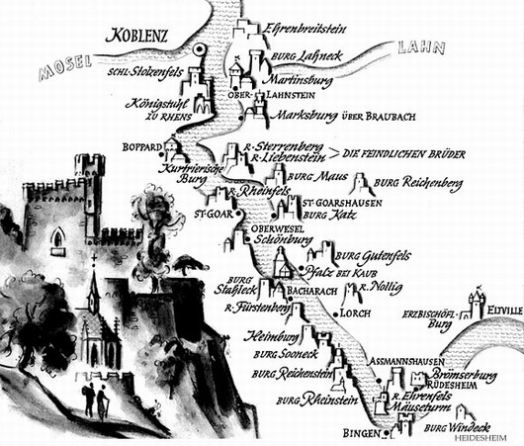
There is no place in the world where so many castles were constructed in such dense clusters than along the Upper Middle Rhine in Germany (Figure B). In this 36 mile stretch alone, over twenty-four strongholds were erected over the course of several centuries of varying sizes and styles, all with specific purposes in mind. Aside from protecting lands, many of the castles served as toll stations along the river. Often perched high on cliffs, they would forcibly stop any ship and exact a toll. This was not regulated; tolls would vary from castle to castle and lord to lord. They would be stopped several times along the river, and if a toll demanded could not be met the ship’s crew would likely be imprisoned, and the cargo taken anyways.
B
The worst of all the toll collectors were known as robber barons. These “barons” were often not of noble lineage and were only appointed by those in power to serve as castellans in their castles when they could not be present. Unfortunately, years could pass by without a single noble returning to a castle to supervise its operation. In this environment, with unquestioned authority, these “barons” behaved, unchecked, as no more than common criminals for centuries.
This reputation of brutality, combined with the Rhine’s naturally perilous currents, made the region a dangerous place to be. Political and religious confrontations were also no stranger to this area since all wanted to lay claim to it. Over time, all but one of the many castles in this region were attacked and destroyed by the ravages of war, as weaponry developed and the thick castle walls were no longer adequate defensively.
By the beginning of the 19th century, the medieval fortresses of this river lay in ruin, overgrown by vegetation; quarried for stones and neglected entirely. It wasn’t until then that the violent river tolling and the throws of war subsided, and people began venturing up and down the Rhine freely, rediscovering its ancient beauty. None were more influential in the recognition of Germany’s hidden cultural history than the Romantic artists of the time. Many great poets, writers and painters travelled along this route and were inspired by the small towns, lush vineyards and the mysterious castle ruins overlooking them all. Because the Romantic Movement was one which appreciated nature and landscape, the Upper Middle Rhine was wholly appealing.
Another aspect of the Romantic Period to thrive along the Rhine was its respect for human feeling and emotion. Its tendency to overvalue the heroics and great deeds of the individual, particularly if the individual went against the constraints or norms of society was great. Once the Romantic artists heard from the locals about legends surrounding their river, their towns, and most importantly their castles, there was no turning back; the muse had met the visionary.
Romantic writers such as Hugo, Twain, Longfellow and Goethe put to paper and shared with the entire world many ancient legends which had previously never drifted far from the Rhineland itself. The publications and elegantly prosed words of these artists when describing the “Romantic” Rhine attracted the attention, hearts and imaginations of the world at large. Tourism boomed, and this rebirthed appreciation for the regions rich cultural history fueled the desire of national unification. The once forgotten and mighty Rhine castles suddenly stood as monuments of pride in a land which struggled to come together for centuries.
By the time Germany finally unified as one nation in 1871, many of the castles were already being reconstructed and restored to their former glory. People everywhere heard of their legends and were flocking to see for themselves these mysterious and elusive hulks perched precariously over the River Rhine. To this day, stories of knights and maidens delight the listener, and the beauty of the landscape inspires the believers. For this, we may thank the generations of families who have passed these stories along and delivered them to the skilled pens of the Romantics, whom have in turn set them in forever into history.

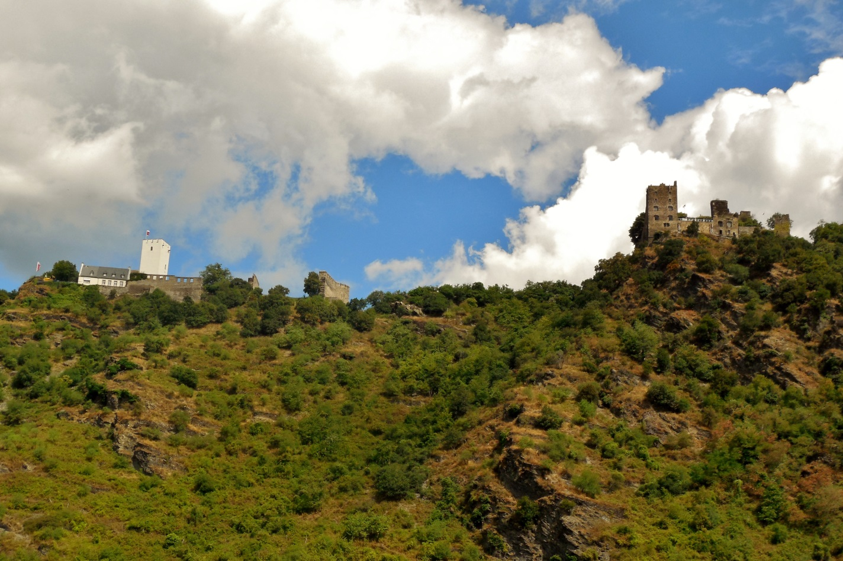
Sterrenberg und Liebenstein
“Star Mountain and Love Stone”
A Brief History
No documented record exists for the exact dates of construction for either of these castles, but evidence suggests Sterrenberg was built in the early 12th century as an Imperial castle to oversee customs in the town of Kamp-Bornhofen, which was in fief to the empire. Liebenstein was constructed during the 13th century, and both castles fell to the Archbishop of Trier during the 14th century. He used them as seats to secure his hold along the right bank of the Rhine in this region until the Maus Castle replaced them in this role shortly thereafter. In the 15th century both castles were deemed uninhabitable and fell to ruin. As to the reason Sterrenberg and Liebenstein were constructed so closely together in the first place – which is unusual – the answer lies in the following legend.
The Hostile Brothers
There once was an old nobleman of Sterrenberg who had two sons, Heinrich and Konrad. Although the brothers were very close, they were opposite in nature. Heinrich was gentle and quiet, while Konrad was bold and brave. The brothers were also raised with an orphaned cousin, Angela, who grew to be a beautiful maiden.
Both brothers were quite taken with the girl, but had different ways of showing their affection. Heinrich was not forthcoming with his feelings for her, and did not express his love. Konrad, on the other hand, was openly flirtatious and it was not long before he wooed the girl and she declared her love for him. Heinrich was disappointed in this, but wanted nothing more than Angela’s happiness, so he resolved himself to the fact he would never have her.
Their father built for Konrad and Angela Liebenstein nearby to Sterrenberg, so they may settle down there to begin their lives together. However, it was not long before Konrad, who was ever one for showing off, was tempted to fight in the Emperor’s holy wars in far-away lands. Despite reprimand from Heinrich and his father, Konrad chose to leave Angela for the excitement and valor to be found on the battlefield.
Years passed with Konrad away and yet Heinrich - being as honest and gentle as he was – never made a move for Angela, who was patiently waiting for her betrothed to return. During this time Heinrich treated Angela as a sister and nothing more. When his father passed away he became the Lord of Sterrenberg and remained wifeless.
Eventually, the day came when Konrad did return. But it was not a great day for Angela because he brought with him a beautiful Greek wife, apparently casting aside his betrothal to her while he was away. Heinrich was furious with his brother then, and no longer did he keep his feelings silent. Cursing Konrad, he challenged him to a duel to the death in defense of their cousin’s honor. Before swords could be drawn however, the heartbroken Angela stepped in and begged the brothers not to fight, reminding them of their once closeness and family ties. As an act of acceptance to her situation, Angela declared she would enter a convent, and no longer be a source of discontent between the two men.
Although the men did not fight, Heinrich could not stand the sight of his brother and replacement bride in the neighboring castle and constructed a massive wall between Sterrenberg and Liebenstein, which can still be seen today. Never did he lose his love for Angela, and it is said that when funeral bells rang for her in the convent below, so too they begin tolling for Heinrich in Sterrenberg above.
Konrad did not escape punishment for his foul behavior and treatment of Angela and Heinrich. It was not long into their marriage that his Greek wife was unfaithful to him, and ran away with one of his closest friends. Bitter and alone, without his brother or Angela to comfort him, and nothing but a stone wall and an empty Sterrenberg to remind him of their lives, Konrad threw himself off the walls of Liebenstein, forever ending the family line of Sterrenberg.

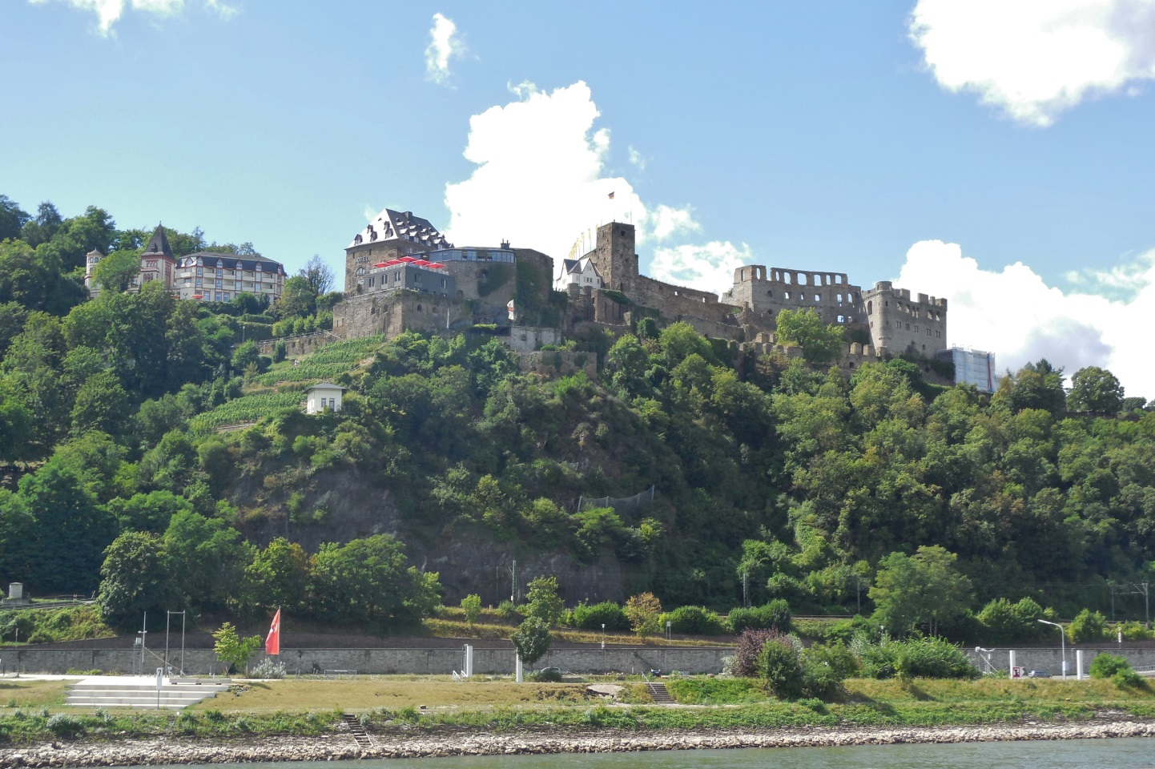
Burg Rheinfels
“Rhine Rock Castle”
A Brief History
Rheinfels was initially constructed in 1245 by the noble Katzenelenbogen family to protect the town of St. Goar and ensure their rights over the river. This fortress is the largest along this part of the Rhine and was expanded upon for centuries. The partial ruins – which are still quite enormous – are only one fifth of the size the castle was during its heyday throughout the 14th and 15th centuries. Rheinfels was notoriously difficult to attack because of its immense fortifications and was the only castle on the river to successfully fend-off French armies during the wars of the 1600’s. During wartime the castle could safely house and feed 5000 people, and outlasted a siege lasting a year. Sadly, the castle was lost when it was abandoned by a cowardly lord when faced with French attack again in the 1700’s. Finally having taken the castle, it became a French priority to destroy it, which is why so little of the castle survives today.
The Linden Tree
In a time when the castle was in its prime, the reigning count had a lovely daughter who fell in love with a young knight by the name of George. Receiving blessings from the count, the betrothal was set and the wedding date scheduled.
Before the vows could be said, George was summoned by the emperor to war against the Swiss confederates, and he had no choice but to leave his betrothed and head into battle. The maiden was heartbroken of course, but found comfort in George’s reassurance that he would return safely to her. To keep her faith alive, he went and found the sapling of a Linden Tree and planted it in her courtyard. He told her as long as this tree flourished and lived, so too did he, and to wait for his return for as long as its branches were strong. The maiden swore her love to him and they parted ways.
Many years went by and the tree grew stronger by day in her courtyard, and her love never wavered for George. Many suitors attempted to win her over, but she stayed loyal to her betrothal. This infuriated an older knight of Berg, Dietrich, who was wealthy beyond need and could not understand the lovely maiden’s refusal to marry him.
When he confronted her, she foolishly told him of the Linden Tree, and George’s parting words, naively thinking this would suffice as a reasonable explanation to the dark knight. On the contrary, this only gave him the opportunity to deceive the maiden. The knight searched the nearby hills and eventually found what he was looking for: a sickly and diseased Linden Tree. In the darkness of night the count snuck into the maiden’s courtyard and uprooted her precious Linden, replacing it with the dying one from the forest. He then stepped back to await the maiden’s discovery of her tree.
Sure enough, the maiden noticed immediately the Linden’s sudden turn for the worst and despaired over her beloved George. She worried and waited over his homecoming, and although other knights were returning from the war, George did not. Thinking enough time had passed and his trick successful, the dark Knight of Berg presented himself yet again before the girl and expressed his desire to marry her. Much to his surprise she still refused and he reminded her of her words about the tree, pointing out its obvious decay. Despite all this, she told him she knew she could only ever love George, even if it meant in death, and refused his offerings.
This rich old knight was enraged and insulted by this, and in a fury unsheathed his dagger and buried it deeply into her chest. She died immediately and he fled the scene in a most cowardly fashion. It was not long however before guilt of conscience caught up with him, and he later hanged himself in shame.
While the maiden’s grave was still fresh young George finally returned to the castle after spending months in the Swiss countryside recovering from his battle wounds. With great sadness the Count of Rheinfels told the young knight of all which transpired and of the loss of his beautiful daughter to the jealous Knight of Berg. George was beside himself with grief and went to the courtyard to lay eyes upon the wilted tree in the garden. He ripped it from the earth and planted white lilies in its place, swearing to love the maiden for eternity, even in death. It is said George spent the rest of his days drowning his sorrows in the company of minstrels, singing songs of a happier life.
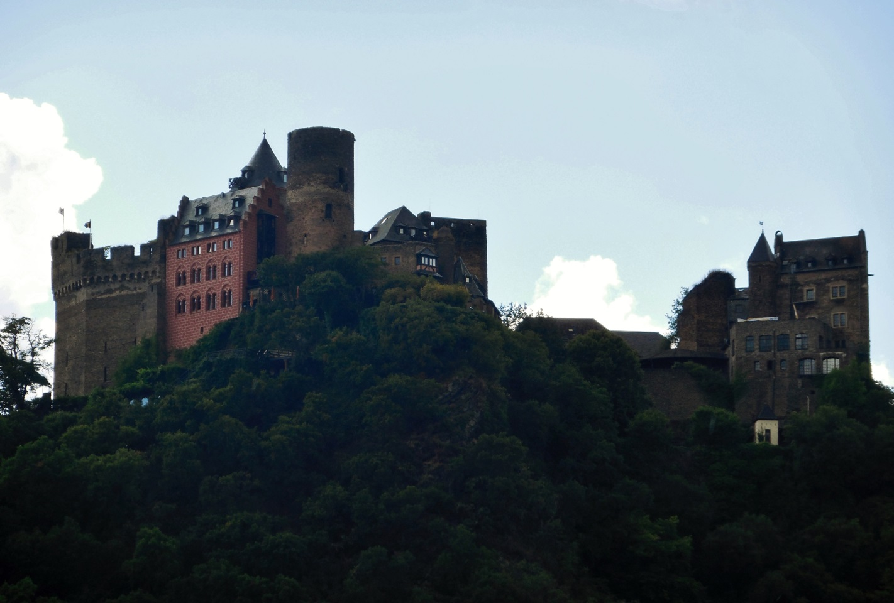
Schönburg
“Beautiful Castle”
A Brief History
First mentioned in history during the 10th century, Schönburg is one of the older castles along the Rhine, as well as one of the largest. The dukes of this castle were responsible for the town of Oberwesel and levying tolls on the river. Schönburg’s history is unique from others of its time because as each duke died off the castle was not left solely to the eldest heir, which was the custom of the Middle Ages. Instead, the castle was shared by all surviving heirs and they each resided there with their families. This tradition is what led Schönburg to its defining physical characteristics, which are several tower keeps rather than the single one typically found in medieval castles. As each individual family made residence within the palace walls, they would construct their own keeps to ensure their safety in case of attack. It is known that during the 14th century and before the French wars, up to twenty-four noble families were living in Schönburg simultaneously. The castle’s name is derived from a popular legend which was born within its walls.
The Seven Sisters
There was once a duke of Schönburg who they say died of disappointment from not producing any sons or male heirs. Instead, the duke fathered seven beautiful daughters who were very close and refused to marry. After the duke’s death, an aunt tried to manage the sisters but it was no use, they were perfectly happy living their splendid lives together in the castle, and did not want to risk being separated by marriage.
This is not to say the seven sisters did not court many suitors, word of their loveliness had spread far and wide, and knights and nobles came to court frequently in hopes of capturing the heart of one of these maidens. The girls relished the attention and compliments given to them by these men and played with their emotions tirelessly. One after another the would-be husbands of the beautiful maidens would leave the castle with broken spirits and deflated egos. None escaped the jokes and scorn of the girls, and before long they earned a reputation of being very unruly, and unwilling to give up their liberty for any man.
After years of seductive taunts and teases, the noble men of the land gathered together at Schönburg and demanded the seven sisters choose husbands from the lot, and none would leave the castle until they did so. The girls responded against the proposition at first, but after conversing silently amongst themselves they conceded to the men and declared they would make their decisions shortly, but only after they were properly ready and prepared for such an announcement.
With that, the girls left the men and returned to their rooms for quite some time, after what seemed like hours a servant arrived and notified the men it was time for them to learn who among them would be marrying the seven beautiful sisters of Schönburg.
They were led outside along the palace walls, where they were directed to look towards the river. To their dismay, the sisters were scurrying away from the castle to a boat which was waiting for them on the River Rhine. Looking back at the men piled along the wall, the girls broke out into scornful laughter, ridiculing the men for their gullibility. On the boat, they shouted at them and mocked them for thinking they would ever give up their happy lives and liberty to become their wives.
It is said the knights and nobles stood dumbstruck as the maidens carried on in their heartless ways without noticing the darkening sky and the choppiness among the waters of the river. Right before their eyes, Father Rhine set in motion a huge wave which capsized the boat, and the lovely maidens, weighted down by their heavy dresses and hearts of lead sank straight to the bottom of the river.
To this day, when the water level is at its lowest, seven rocks become visible off the shore beneath Schönburg. These are the seven stone hearts of the seven beautiful sisters for which the castle gets its name.

Pfalzgrafenstein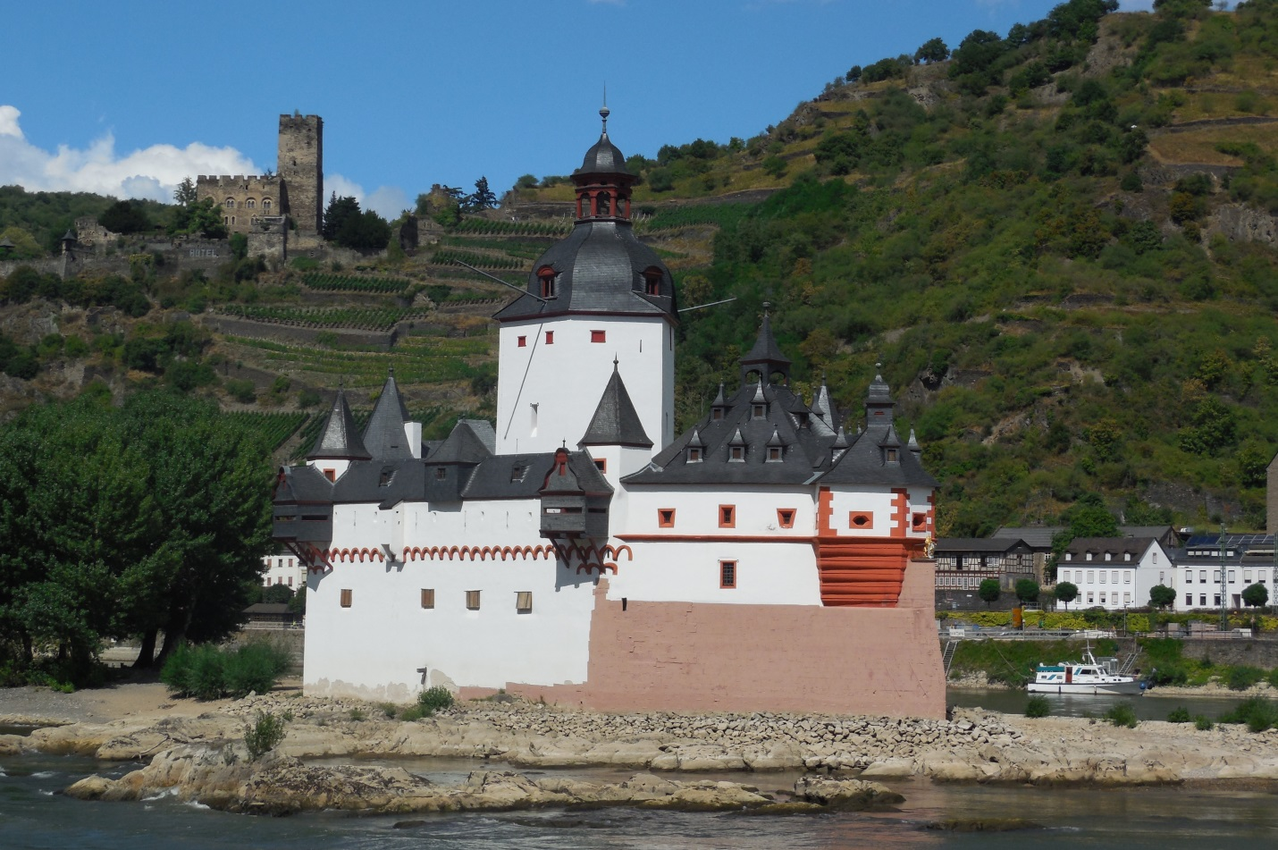
“Count Palatine’s Stone”
A Brief History
Built in 1327 by Ludwig of Bavaria, this castle was constructed for the sole purpose of collecting tolls, and not housing nobles, which it did successfully until 1866 for the town of Kaub. This is only one of the unique qualities of the Pfalz. Another is in the design, since it was erected on an island in the middle of the river to look like a ship. The pointed bow is fortified to serve as an icebreaker and the single tower is reminiscent of a mast or smokestack. There is only one other castle in the world which resembles this, and that is on Lake Geneva, Switzerland. The third unique quality of the Pfalz is it is the only castle along the Rhine to never be damaged during an act of war. The French left it alone in the 17th and 18th centuries, and it survived unscathed through both World Wars. It did attain military notoriety in 1813 when Blücher constructed an innovative pontoon bridge here and led an army troops in the direction of Napoleon, which led to his eventual downfall. The final unique quality of the Pfalz rests with this legend, and uncommon happy ending.
The Palatinate
In the time near the Pfalz’s creation, the Count of the Palatine was Conrad, who was tightly associated with the Emperor Barbarossa. Although he had all the worldly riches he could need, he lacked the one thing he desired most and that was a son, an heir to his titles and fortunes. Instead Conrad had a lovely daughter, Agnes, who was reaching a marrying age. The time was coming for the selection of a suitable husband for her, one who would strengthen the family’s position in the land.
Many noble men came to court Agnes, but she was not interested in any of them, for she had already fallen in love with a knight named Henry, who was of the family Brunswick, known enemies to the emperor and therefore off-limits to Agnes. When she stood in defiance to her father, refusing his choices for husbands and declaring her love for Henry of Brunswick, he became angry; swearing swore to lock her away until she came to her senses.
With that, Conrad sent her, along with her ever supportive mother, to the Pfalz to be locked inside, away from the world and most importantly, Henry. Agnes was distraught, but held her resolve, and many months passed with silence from the castle.
During this time, Henry never let his love for Agnes fade, and it wasn’t long before he set out for the Pfalz under the cover of darkness in a rowboat with a priest by his side. When they arrived, Agnes was overjoyed and her mother saw the true love between the two and consented to their wishes; she stood as witness while the priest married the two lovers.
All this was done in great secret, but as it became clear Agnes was with child the time had finally come to tell Conrad; on his next visit there was no denying Agnes’ condition. The situation was explained by his wife, but Conrad raged and cursed throughout the entire castle. He felt betrayed and trapped, because now he had no choice but to go before the emperor and tell him of their indiscretions.
When the day finally came, Conrad broke the news slowly to the emperor, expecting dire consequences. Instead, it is said Emperor Barbarossa only gave a smile and rejoiced, because he had long been searching for a way to reunite with the Brunswick family, and this predicament proved the perfect circumstance.
Elated at this turn of events, Conrad returned to the Pfalz to relay the good news, and was met with his first grandchild and heir to the Palatinate. The union of the families brought such joy that the Count ordered one room of the Pfalz always contain a cradle, in memory of the blessed event.

Burg Sooneck 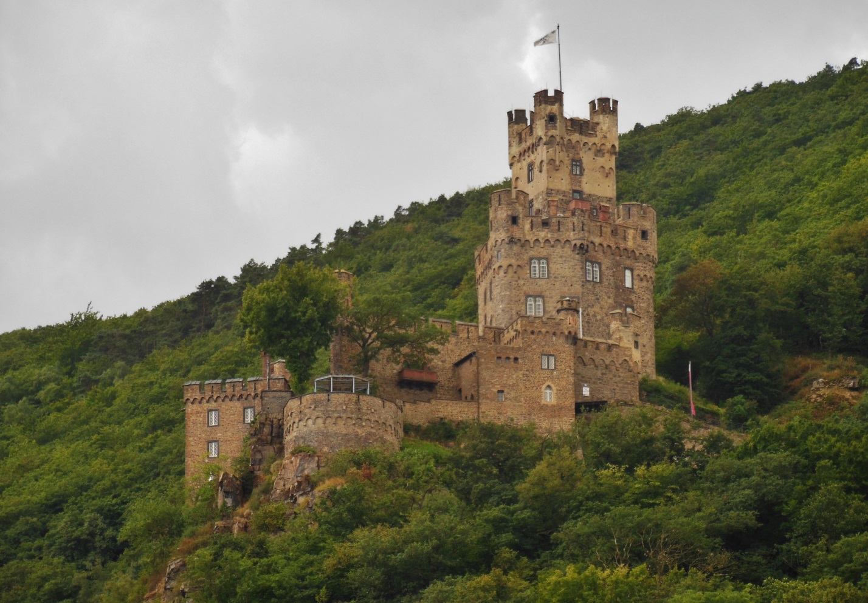
“Forest Corner Castle”
A Brief History
Sooneck was most likely constructed during the 11th century by the abbey Kornelimünster to defend their interests along the edge of the forest and against would be attackers from the Rhine. Because the Abbey’s power was spread so thinly, the castle was put under the care of castellans, which earned it a most notorious reputation as a den for robber barons. For centuries, the barons residing here led savage lives pillaging merchant vessels en route up and down the river. Their brutality and theft upset trade and pilgrimage until the 13th century when Rudolph of Hapsburg ended the reign of the robber barons. Evidence of their harsh nature exists to this day, in the form of the following legend.
The Blind Archer
In the time of the robber barons prime, there was such a baron living in Sooneck Castle. His name was Siebold, and he had a dark reputation to match his title, and was known throughout the land to be quite cruel and underhanded. Naturally, Siebold had cause for feud with any other noble who did not live by his ruthless standards.
One such noble was the good knight Hans, who was a legendary archer throughout the Rhineland. He stood for all which was honest and decent, and certainly did have cause to distrust and dislike Siebold of Sooneck. One day, while Hans was traveling through the forest, he was ambushed by none other than the baron and his men, who immediately took him as prisoner.
Siebold took great pleasure in the torture of Hans, and burned out his eyes while he was in the dungeons of Sooneck. In this way, he took from the good knight his greatest asset; the sight needed for his excellent marksmanship with the bow and arrow. Many months passed by with Hans left to suffer alone before one day he was summoned to a banquet Siebold was holding for his fellow robber barons in the great hall.
The baron was known to show off and brag to his comrades, and he could not miss the opportunity to parade his captive before them, the once feared and legendary archer Hans. Before them in the hall, the knight bore signs of captivity: he was dirty and thin, worn down and weak, with two dark sockets where his eyes once were.
Seeking to humiliate Hans for the benefit of his guests, Siebold presented him with a challenge: to hit a target using sound alone, to prove he really was the greatest bowman in all the land.
The baron’s men presented him with the tools required, a single arrow and a bow. Siebold then announced he would toss his wine goblet into the air, and by the sound it made at it clanged to the ground Hans was to hit it, and if he did, he would be released. No one in the room truly believed this claim to be true; all knew Siebold was much too proud to give up his prize.
With Hans in position across the room, all went silent and the baron tossed the goblet into the air. With a clamor, it hit the stone floor of Sooneck, but Hans did not release his arrow. Irritated with the insubordination, Siebold demanded of the blind archer, “SHOOT!”
And Hans did.
Before the baron could even finish the word, the archer let loose his arrow and it sailed through the hall and directly into the neck of Baron Siebold, to where the sound of his voice had issued forth. With a brief gurgle and a flow of blood the baron fell to the floor, dead. The famous archer of the Rhineland had proven himself and landed his mark.
The baron’s comrades and servants fled the castle in fear as the weakened Hans simply stood quietly in the corner. It is said that he was weeping gently, despite the burned and scarred sockets of his eyes.

Burg Reichenstein 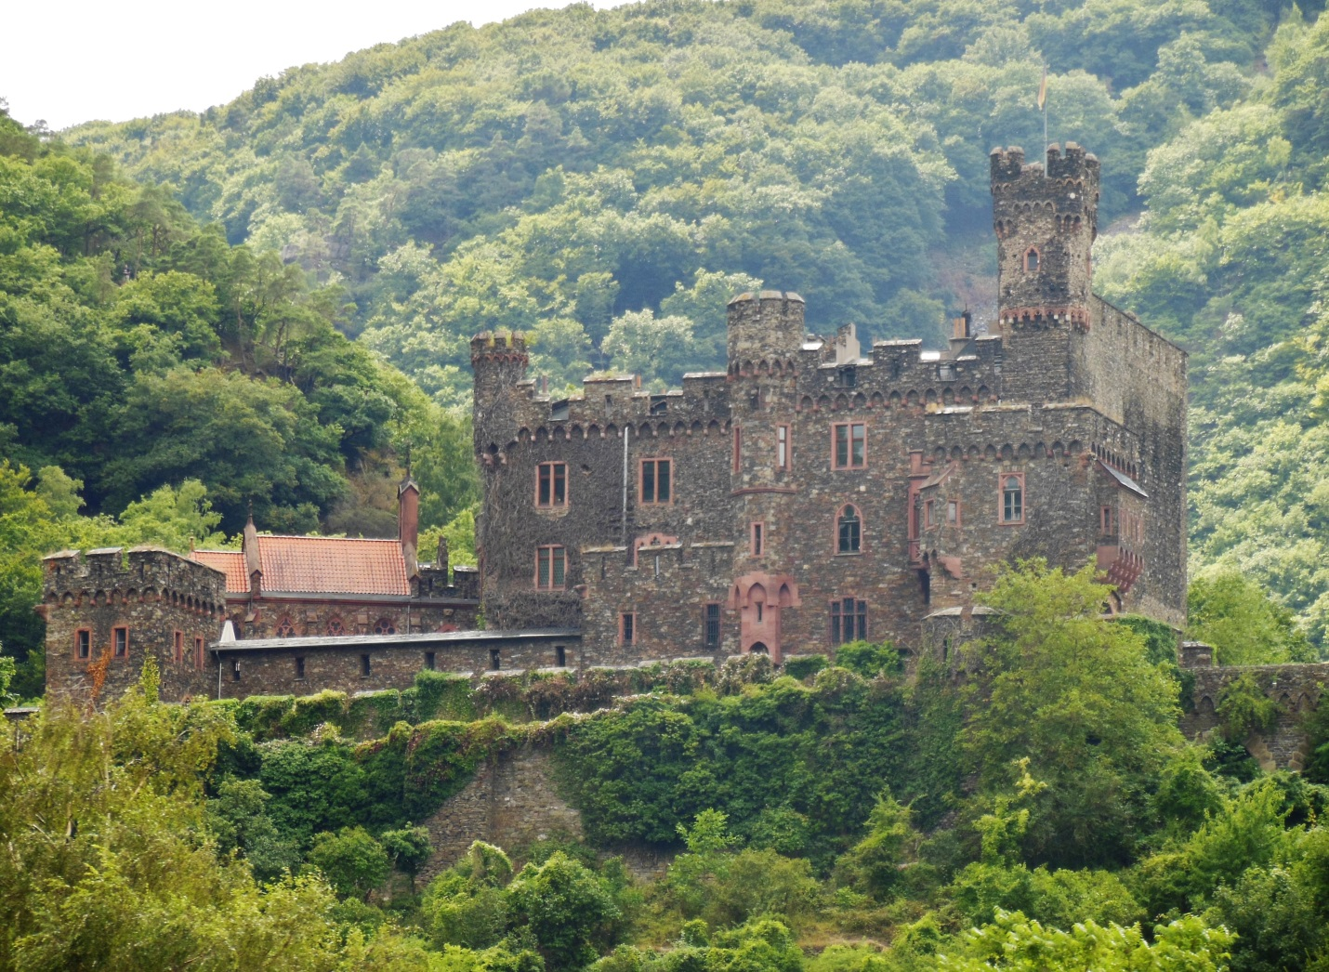
“Rich Stone Castle”
A Brief History
The oldest parts of this castle date back to the 11th century, but it has been destroyed and rebuilt many times since then. Like Burg Sooneck, it was owned by the abbey Kornelimünster and became another castle to be inhabited by robber barons. This is what brought Reichenstein so much destruction during the 13th century. The first time was in 1253 when the Archbishop of Mainz and the army of the town association attacked the castle and razed its walls in order to deter robber barons from coming back. This effort was unsuccessful however, and with so much political turbulence in the area it was not long before the barons rebuilt Reichenstein stronger than ever before.
When finally the government came to rest, Rudolph von Hapsburg marched on the Rhineland robber barons with express intent to finish them once and for all. In this he was successful, as the following legend relates.
The Headless Ghost
In the final days of the robber barons, one of the most notorious of all was Dietrich von Hohenfels of Reichenstein. When he stood before Rudolph von Hapsburg on the day of his judgment he knew there would be no chance of his survival. Hapsburg had sworn to hang like dogs all the robber barons in the land and this was to be the fate for Dietrich and his nine sons, whom he reared to live as he did: as thieving, murdering, lawless lords.
The robber baron of Reichenstein wished his sons to be spared, citing they were only doing as their father taught them to do. He pled with Hapsburg not to hang them, so that his soul may rest in peace knowing he had not destroyed their lives. Rudolph considered for a moment and then offered a bargain. He told Dietrich he would be beheaded while standing, and every one of his nine sons his headless body managed to walk past before it fell would be spared of the hangman’s noose.
Dietrich was discouraged, but he could not refuse the offer. The stage was set and his sons were brought out and lined up one next to another, shoulder to shoulder. The executioner was an excellent swordsman, and waited at the beginning of the line. In the tall trees nearby nine readied nooses could be seen swaying in the breeze.
Baron Hohenfels stepped to his place and the executioner swung, Dietrich’s head came off in one clean cut, and took its first step. Hapsburg and his men looked on in disbelief as the body continued walking past every one of the men. As Dietrich’s headless body passed the ninth and final son it fell, issuing forth and covering Hapsburg in a shower of blood.
Utterly disgusted, and convinced there was dark magic about Reichenstein, he stayed true to his word and released the nine sons, warning them to avoid the paths their father led them to. Without another look back, Rudolph von Hapsburg and his men left the ruined castle forever.
As for the sons, nothing was ever heard of them again, and they too did not stay near their former home. Dietrich, it is said, never found peace despite his sons being saved, and to this day, a headless ghost can be sometimes seen in roaming the halls of Reichenstein, caught forever between the land of the living and the dead as punishment for his soul’s wicked deeds on the River Rhine.

Burg Rheinstein 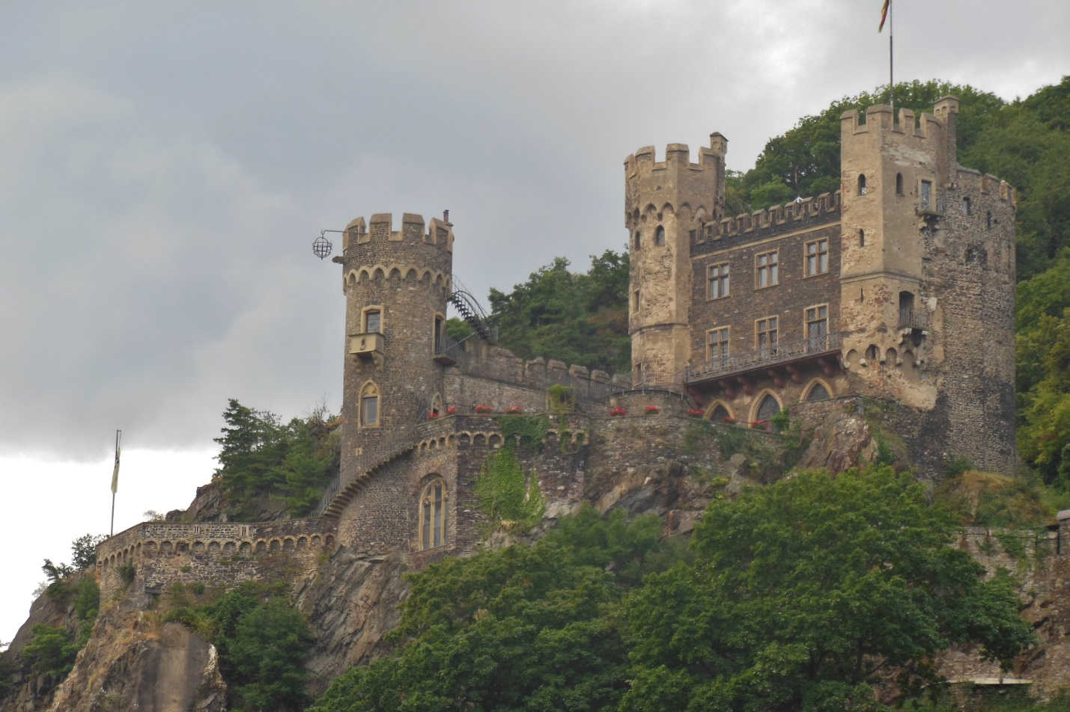
“Rhine Stone Castle”
A Brief History
Rheinstein was constructed in the end of the 13th century for two purposes, the first was to warn off and protect against the robber barons which had plagued the Rhine in this area for centuries. The second reason was for levying tolls which were sanctioned by the Archbishop of Mainz. One of this castle’s most distinctive features is the cage hanging off the front tower, which was there to remind all who passed the consequences of not paying dues, or for living against the authority of the archbishop.
The castle was successful in its endeavors and served well for the people along the Rhine until the 17th century when the French crossed the river and destroyed every castle they came to.
The Wooing
During the quiet times after the robber barons had finally been vanquished, the castles of Reichenstein and Rheinstein lived in peace as neighbors above the River Rhine. Reichenstein was but a broken hulk of its former glory, and occupied by the poor but sweet Kuno. In Rheinstein there lived and old knight, Diethelm, with his beautiful daughter Gerba. Kuno and Gerba grew up together as playmates, and Diethelm thought very fondly of the lad, considering him almost as a son or nephew.
Of course as they grew and blossomed into adults, it was not long before the childhood friends developed feelings of true love for each other. One evening while they walked the courtyard gardens of Rheinstein together, Kuno presented Gerba with a fine white Limousin mare he obtained and reared for her in his own castle, Reichenstein. It was a gift to declare his undying devotion to her. To this Gerba was delighted, and the couple parted, Kuno promising to seek her father’s blessings in their union.
Kuno did however face a dilemma. It was customary of the times for a suitor to send an elder family member as an ambassador to the family of the intended bride to propose a marriage and arrange dowries. The problem was Kuno had no family left in this world to send, save that of a remarkably unsavory and wealthy uncle, Kurt. Although he personally disliked the man, Kuno felt he had no other options if he wanted his proposal to be done in accordance with all traditional customs.
Kuno went before his uncle and explained his request nervously, knowing him to be cruel and selfish, he expected rejection. However, to his surprise, after only musing for a moment Kurt agreed to travel to Rheinstein, seeking Gerba as Kuno’s bride. Elated, Kuno went to Gerba immediately and told her the news in her gardens, and they were both incredibly happy.
Kurt did indeed have plans of his own, and more true to his character. He had long heard stories of Gerba’s fair beauty and thought to present himself instead as a potential bridegroom to Diethelm, casting aside all notions of traditional custom. He cared not at all for the feelings of Kuno or the maiden.
When the day came, Diethelm received Kurt with full honors, and listened to the lord’s wishes to marry his daughter. Being as wealthy as Kurt was, Diethelm could not deny the great opportunity it would be to secure this bountiful union for him and his daughter. He accepted; quite naïve of Gerba’s feeling for Kuno. The wedding was set for the following day.
Gerba heard the news from her father and was devastated. She pled, begged, and attempted to defy him, refusing the union. He was angered over her sudden insolence and told her she had no choice, she would marry the old Lord Kurt and no more would be said of it. Defeated, Gerba spent the night weeping in her gardens.
The news was leaked to Kuno, who was also devastated. Having no wealth, armies or power of his own, he knew he had no options. He was also far too gentle to rise against Lord Diethelm’s wishes for his daughter. He spent the evening in his tower, looking over cliff to the gardens of Rheinstein.
The next day the bridal party assembled. The leaders of this procession were Lord Kurt on his mighty warhorse and the reluctant Gerba on her white Limousin. They were followed by Lord Diethelm, the court of Rheinstein and all its peasants, en route to St. Clement’s Chapel along the river. Kuno watched the scene sadly from his tower in Reichenstein.
As the party slowed before the chapel a sudden swarm of bees circled Gerba’s Limousin and stung the startled horse several times. Before any could intervene, she reared back and ran as fast as her legs would carry her towards home. Much to the dismay of Lord Kurt, this meant not Rheinstein, but the place which the horse was raised - Reichenstein.
Kurt kicked his warhorse in pursuit of the maddened Limousin, but it was no match for the other’s grace and speed as it climbed the steep cliffs to Kuno’s castle. Watching this chase from his tower, Kuno ordered the drawbridge lowered and raced to his courtyard. He was there in time to see Gerba ride in on her steaming mare, but did not see or hear his uncle’s approach. Upon closer inspection, he saw the mighty warhorse had stumbled along the path and thrown his heavy rider onto the rocks below. Kurt was no more.
It was not long before Gerba’s father arrived on the scene and saw what transpired. He was no stranger to legend and fate and suddenly realized, upon seeing his daughter and Kuno together, that they were in love. Considering the situation, the lord announced it would be Gerba and Kuno to be married on that day.
The wedding and celebration were marvelous, and it is said the couple lived many happy years before being buried together underneath the chapel of St. Clements.
Der Maus Turm 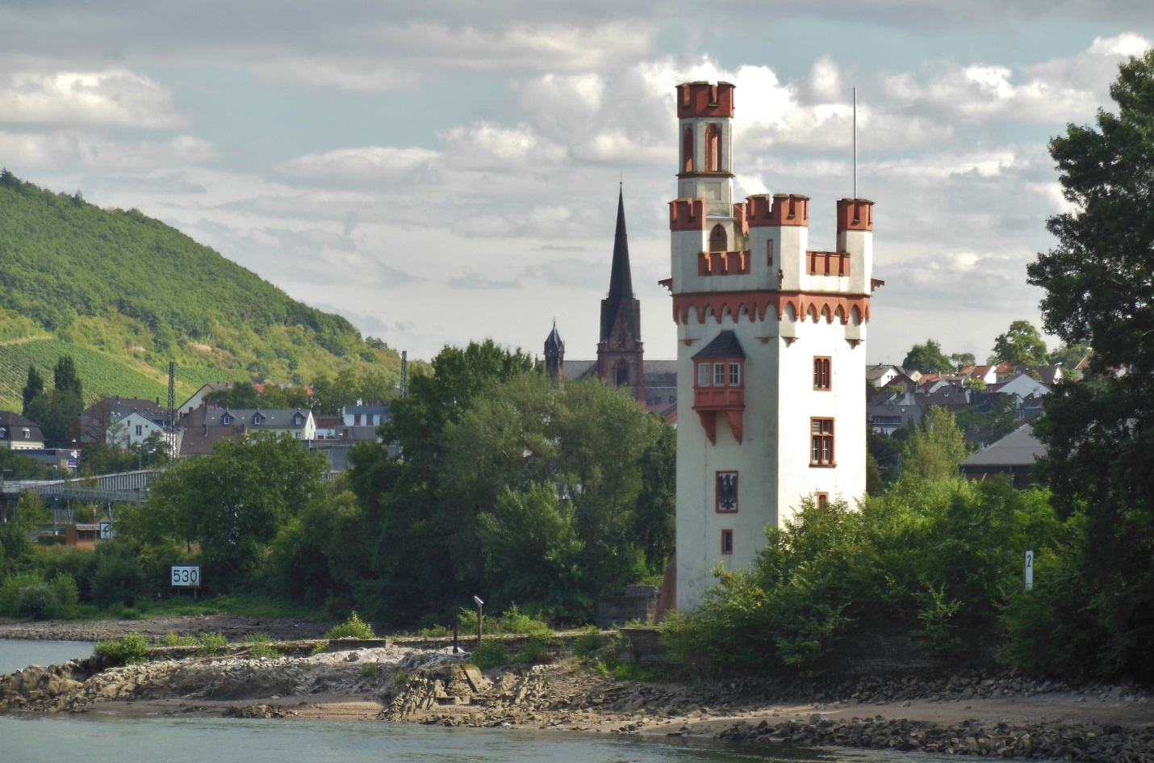
“The Mouse Tower”
A Brief History
It is difficult to say exactly when this tiny turret came to be, evidence suggests the Romans first had a tower here during their heyday. It was then refortified by the area bishop sometime in the 10th century. It stands at the northern entrance to the Upper Middle Rhine near Bingen, and served as a signal and toll tower for nearly 1000 years until 1866. Not truly a castle, it never housed any nobles, except for possibly once, and only briefly, as relayed in the following legend.

The Story of Bishop Hatto
A thousand years ago the ruler of Bingen was Bishop Hatto, who was known to be a selfish and punishing lord over his people. As the winter months set in along the Rhine, the bishop had no concerns, for the harvest had been plentiful and his barns all were stuffed with the necessary grains for him to survive until spring very comfortably.
The peasants and serfs however were not so carefree. Bishop Hatto was stingy with his shares, and took more than he needed for himself from the poor. Day after day they came begging and crying to the Bishop, pleading with him to open his barns and let them take what they needed to survive the winter. Despite constant scoffs and refusals, still they came, dirty and starving, until Hatto could take it no more. He promised the people that on the morrow he would open one of his barns and let everyone in to get their grain.
The next day it became clear the bishop had no intention of this. He did open the doors, and they were all allowed to enter, but it was a trap. The bishop had all the grain removed the night before, and when the unfortunate peasants tried to leave they discovered Bishop Hatto had trapped them inside. The screams of his people meant nothing to him as he ordered his servants to burn the barn - which they did.
It is said that as the flames rose, the Bishop remarked scornfully the people wailing sounded much indeed like the squeaks of little mice among the corn. Without a second thought or pang of guilt, the bishop then retired to his home.
But there was indeed the squeaking of mice, as their nooks and crannies inside the barn were destroyed by fire they poured out by the thousands. Enraged by this loss and what they heard, they knew which way to turn, and who to blame.
By morning the bishop’s servants were in alarm, mice had eaten through the pantry and through the walls. They alerted the bishop who was hit with sudden fear when he saw they had even eaten is portrait out of a frame. Without a moments delay he hastened to relocate to his toll tower on the Rhine - certain they could not follow him there – until the mice could be disposed of.
And so he boated across the mighty flowing river and into the top of his tower. He did not find peace there however, and watched from the window with horror as armies and armies of rodents from far and wide were joining together and gathering on the shores. The river drowned many, but still they came and soon their masses were circling and climbing the tower in search of cruel Bishop Hatto.
They found him huddled in fear and begging for mercy, but he found none from the rodents of the barns. Without remorse, they chewed him down to the bone as punishment for his wrongdoings, before dismissing themselves back across the Rhine.

Works Cited
Barrow, Sir John. A Family Tour Through South Holland: Up the Rhine, and Across the Netherlands, to Ostend. London: John Murray, 1831. Web. 2013. <http://books.google.com>.
Bonnet, James. "How the Great Myths and Legends Were Created." 2013. writersstore.com. The Writers Store Incorporated. Web. 10 December 2013. <http://www.writersstore.com/how-the-great-myths-and-legends-were-created/>.
CALTIM Designs. Schloss Reichenstein. 2010. Web. 10 December 2013. <http://www.caltim.com/reichenstein/#INTRODUCTION>.
Castle Rock Rich Society. Burg Reichenstein. 2013. Web. 10 December 2013. <http://www.burg-reichenstein.de/geschichte/raubritternest/index.html>.
Familie Hecher. Burg Rheinstein. 2013. Web. 10 December 2013. <http://www.burg-rheinstein.de/burg/hi.htm>.
Familie Hüttl . Castle Hotel of Shoenburg. 2013. Web. 10 December 2013. <http://www.hotel-schoenburg.com/>.
German Castle Association. Burg Direkt. November 2008. Web. 10 December 2013. <http://www.burg-direkt.de/>.
Horn, W. O. von. The Rhine: History and Legends of it's Castles, Abbeys, Monasteries, and Towns. Trans. Chris Benson. Wiesbaden: Julius Niedner, 1872. Web. <www.books.google.com>.
Hugo, Victor. The Rhine. New York: Wiley & Putnam, 1845. Web. 2013. <http://books.google.com>.
Loreley Info. Castles on the Rhine River in Germany. 2013. Go_On Sofware Corporation. Web. 10 December 2013. <http://www.loreley-info.com/eng/rhein-rhine/castles.php>.
Piegler, Lare. "Spirits of Reichenstein Castle." 2009. WorldReviewer.com. Web. 10 December 2013. <http://www.worldreviewer.com/travel-guides/paranormal/spirits-of-reichenstein-castle/15304/>.
Recht, Roland. The Rhine: Culture and Landscape at the Heart of Europe. London: Thames & Hudson, 2001. Print.
ROLL. Rhine River. 2013. Web. 10 December 2013. <http://www.rollintl.com/roll/rhine.htm>.
Ruland, Wilhelm. Legends of the Rhine. Munich: Library of Alexandria, 1906. Web. <http://books.google.com>.
Snowe, Joseph. The Rhine: Legends, Traditions, History from Cologne to Mainz. Vol. II. London: J. Madden & Co., 1839. Web. 2013. <http://books.google.com>.
Spence, Lewis. Hero Tales and Legends of the Rhine. New York: Dover Publications, Inc., 2011. Web. 10 December 2013. <http://www.sacred-texts.com/neu/lr/lr12.htm>.
Steves, Rick. Rick Steves' Europe. 2013. Through the Back Door, Inc. Web. 10 December 2013. <http://www.ricksteves.com/>.
Taylor, Robert R. The Castles of the Rhine: Recreating the Middle Ages in Modern Germany. Waterloo: Wilfrid Laurier University Press, 1998. Web.
Tourist Information St. Goar. History of Castle Rheinfels. 2012. Web. 9 December 2013. <http://www.st-goar.de/734-1-geschichte-burg-rheinfels-1.html>.

Linden Tree – A large tree found in Europe which is known to live for hundreds of years.
Limousin – An extinct French breed of horse for both sporting and riding, they were known to be elegant, hardy, and sure-footed.
Warhorse – A stocky and very strong horse used to carry heavy armored knights into battle.
Bees – In the oldest of Rhine legends, bees, hornets and gadflies were considered to be water fairies.

