Hot Standby Router Protocol
Topology
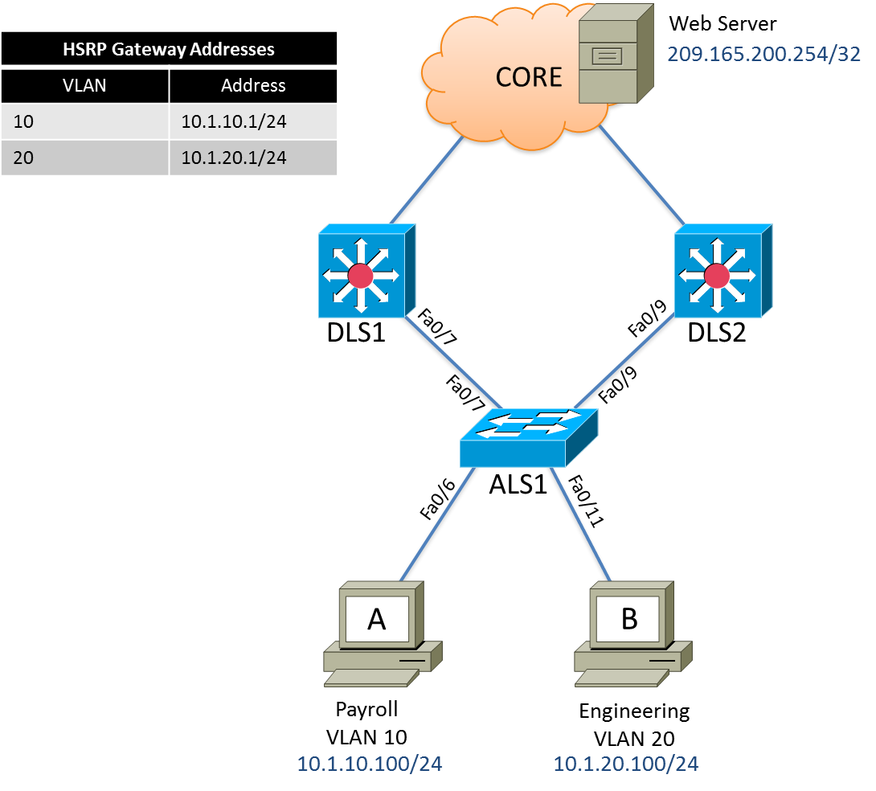

Objective
- Configure HSRP to provide redundant, fault-tolerant routing to the Core network Web Server.

Background
Hot Standby Router Protocol (HSRP) is a Cisco-proprietary redundancy protocol for establishing a fault-tolerant default gateway. It is described in RFC 2281. HSRP provides a transparent failover mechanism to the end stations on the network. This provides users at the access layer with uninterrupted service to the network if the primary gateway becomes inaccessible.
Step 1: Prepare the switches for the lab.
Switches will come preloaded with a baseline configuration as follows:
Switch(config)# hostname ALS1
ALS1(config)# no ip domain-lookup
ALS1(config)# line con 0
ALS1(config-line)# logging synchronous
ALS1(config-line)# exec-timout 0 0
ALS1(config-line)# exit
ALS1(config)# vtp domain cisco
ALS1(config)# vtp mode transparent
ALS1(config)# spanning-tree mode rapid-pvst
ALS1(config)# vlan 10
ALS1(config-vlan)# name Payroll
ALS1(config-vlan)# vlan 20
ALS1(config-vlan)# name Engineering

Switch(config)# hostname DLS1
DLS1(config)# no ip domain-lookup
DLS1(config)# line con 0
DLS1(config-line)# logging synchronous
DLS1(config-line)# exec-timout 0 0
DLS1(config-line)# exit
DLS1(config)# vtp domain cisco
DLS1(config)# vtp mode transparent
DLS1(config)# spanning-tree mode rapid-pvst
DLS1(config)# vlan 10
DLS1(config-vlan)# name Payroll
DLS1(config-vlan)# vlan 20
DLS1(config-vlan)# name Engineering

Switch(config)# hostname DLS2
DLS2(config)# no ip domain-lookup
DLS2(config)# line con 0
DLS2(config-line)# logging synchronous
DLS2(config-line)# exec-timout 0 0
DLS2(config-line)# exit
DLS2(config)# vtp domain cisco
DLS2(config)# vtp mode transparent
DLS2(config)# spanning-tree mode rapid-pvst
DLS2(config)# vlan 10
DLS2(config-vlan)# name Payroll
DLS2(config-vlan)# vlan 20
DLS2(config-vlan)# name Engineering

Step 2: Configure the host IP settings.
Configure each host with the IP address, subnet mask, and default gateway shown in the topology.
Step 3: Configure trunks between switches.
Configure trunks from DLS1 and DLS2 to ALS1. The switchport trunk encapsulation {isl | dot1q} command is used because these switches also support ISL encapsulation.

DLS1(config)# interface fastEthernet 0/7
DLS1(config-if)# switchport trunk encapsulation dot1q
DLS1(config-if)# switchport mode trunk
DLS1(config-if)# switchport trunk allowed vlan 10,20
DLS1(config-if)# no shutdown

DLS2(config-if)# interface fastEthernet 0/9
DLS2(config-if)# switchport trunk encapsulation dot1q
DLS2(config-if)# switchport mode trunk
DLS2(config-if)# switchport trunk allowed vlan 10,20
DLS2(config-if)# no shutdown

ALS1(config-if)# interface fastEthernet 0/7
ALS1(config-if)# switchport mode trunk
ALS1(config-if)# switchport trunk allowed vlan 10,20
ALS1(config-if)# no shutdown
ALS1(config-if)# interface fastEthernet 0/9
ALS1(config-if)# switchport mode trunk
ALS1(config-if)# switchport trunk allowed vlan 10,20
ALS1(config-if)# no shutdown

Step 4: Assign a root switch and backup root switch for each VLAN.
- Configure DLS1 as the root bridge for VLAN 10 and backup root bridge for VLAN 20.

DLS1(config)# spanning-tree vlan 10 root primary
DLS1(config)# spanning-tree vlan 20 root secondary

- Configure DLS2 as the root bridge for VLAN 20 and backup root bridge for VLAN 10.

DLS2(config)# spanning-tree vlan 20 root primary
DLS2(config)# spanning-tree vlan 10 root secondary

Step 5: Configure access ports.
Configure the host ports on ALS1. The following commands configure the switch port mode as access, place the port in the proper VLANs, and turn on spanning-tree PortFast for the ports.
ALS1(config)# interface fastEthernet 0/6
ALS1(config-if)# switchport mode access
ALS1(config-if)# switchport access vlan 10
ALS1(config-if)# spanning-tree portfast
ALS1(config-if)# no shutdown

ALS1(config)# interface fastEthernet 0/11
ALS1(config-if)# switchport mode access
ALS1(config-if)# switchport access vlan 20
ALS1(config-if)# spanning-tree portfast
ALS1(config-if)# no shutdown

Step 6: Configure Layer 3 functions
DLS1 and DLS2 need to be configured for Inter-VLAN routing between VLANs 10 and 20. A loopback interface is also created to simulate the presence of a web server in the core network.
DLS1(config)# ip routing
DLS1(config)# interface vlan 10
DLS1(config-if)# ip address 10.1.10.2 255.255.255.0
DLS1(config-if)# exit
DLS1(config)# interface vlan 20
DLS1(config-if)# ip address 10.1.20.2 255.255.255.0
DLS1(config-if)# exit
DLS1(config)# interface loopback 1
DLS1(config-if)# description Simulated core network web server
DLS1(config-if)# ip address 209.165.200.254 255.255.255.255

DLS2(config)# ip routing
DLS2(config)# interface vlan 10
DLS2(config-if)# ip address 10.1.10.3 255.255.255.0
DLS2(config-if)# exit
DLS2(config)# interface vlan 20
DLS2(config-if)# ip address 10.1.20.3 255.255.255.0
DLS2(config-if)# exit
DLS2(config)# interface loopback 1
DLS2(config-if)# description Simulated core network web server
DLS2(config-if)# ip address 209.165.200.254 255.255.255.255
Step 7: Configure HSRP interfaces and enable routing.
HSRP provides redundancy in the network. The VLANs can be load-balanced by using the standby group priority priority command.
Each route processor can route between the various SVIs configured on its switch. In addition to the real IP address assigned to each distribution switch SVI, assign a third IP address in each subnet to be used as a virtual gateway address. HSRP negotiates and determines which switch accepts information forwarded to the virtual gateway IP address.
The standby command configures the IP address of the virtual gateway, sets the priority for each VLAN, and configures the router for preempt. Preemption allows the router with the higher priority to become the active router after a network failure has been resolved.
In the following configurations, the priority for VLAN 10 is 110 on DLS1, making it the active router for that VLAN. VLAN 20 has a priority of 90 on DLS1, making DLS1 the standby router for this VLAN. DLS2 is configured to be the active router for VLAN 20 with a priority of 110, and the standby router for VLAN 10 with a priority of 90.

DLS1(config)# interface vlan 10
DLS1(config-if)# standby 10 ip 10.1.10.1
DLS1(config-if)# standby 10 preempt
DLS1(config-if)# standby 10 priority 110
DLS1(config-if)# exit

DLS1(config)# interface vlan 20
DLS1(config-if)# standby 20 ip 10.1.20.1
DLS1(config-if)# standby 20 preempt
DLS1(config-if)# standby 20 priority 90
DLS1(config-if)# exit

DLS2(config)# interface vlan 10
DLS2(config-if)# standby 10 ip 10.1.10.1
DLS2(config-if)# standby 10 preempt
DLS2(config-if)# standby 10 priority 90
DLS2(config-if)# exit

DLS2(config)# interface vlan 20
DLS2(config-if)# standby 20 ip 10.1.20.1
DLS2(config-if)# standby 20 preempt
DLS2(config-if)# standby 20 priority 110
DLS2(config-if)# exit

Step 8: Verify the HSRP configuration.
- Issue the show standby command on both DLS1 and DLS2.
DLS1# show standby
Vlan10 - Group 10
State is Active
4 state changes, last state change 02:20:48
Virtual IP address is 10.1.10.1
Active virtual MAC address is 0000.0c07.ac0a
Local virtual MAC address is 0000.0c07.ac0a (v1 default)
Hello time 3 sec, hold time 10 sec
Next hello sent in 1.312 secs
Preemption enabled
Active router is local
Standby router is 10.1.10.3, priority 90 (expires in 9.936 sec)
Priority 110 (configured 110)
Group name is "hsrp-Vl10-10" (default)
Vlan20 - Group 20
State is Standby
1 state change, last state change 02:30:01
Virtual IP address is 10.1.20.1
Active virtual MAC address is 0000.0c07.ac14
Local virtual MAC address is 0000.0c07.ac14 (v1 default)
Hello time 3 sec, hold time 10 sec
Next hello sent in 2.160 secs
Preemption enabled
Active router is 10.1.20.3, priority 110 (expires in 9.008 sec)
Standby router is local
Priority 90 (configured 90)
Group name is "hsrp-Vl20-20" (default)

DLS2# show standby
Vlan10 - Group 10
State is Standby
4 state changes, last state change 02:22:09
Virtual IP address is 10.1.10.1
Active virtual MAC address is 0000.0c07.ac0a
Local virtual MAC address is 0000.0c07.ac0a (v1 default)
Hello time 3 sec, hold time 10 sec
Next hello sent in 2.224 secs
Preemption enabled
Active router is 10.1.10.2, priority 110 (expires in 9.728 sec)
Standby router is local
Priority 90 (configured 90)
Group name is "hsrp-Vl10-10" (default)
Vlan20 - Group 20
State is Active
2 state changes, last state change 02:31:53
Virtual IP address is 10.1.20.1
Active virtual MAC address is 0000.0c07.ac14
Local virtual MAC address is 0000.0c07.ac14 (v1 default)
Hello time 3 sec, hold time 10 sec
Next hello sent in 0.944 secs
Preemption enabled
Active router is local
Standby router is 10.1.20.2, priority 90 (expires in 9.216 sec)
Priority 110 (configured 110)
Group name is "hsrp-Vl20-20" (default)

- Issue the show standby brief command on both DLS1 and DLS2.
DLS1# show standby brief
P indicates configured to preempt.
|
Interface Grp Pri P State Active Standby Virtual IP
Vl10 10 110 P Active local 10.1.10.3 10.1.10.1
Vl20 20 90 P Standby 10.1.20.3 local 10.1.20.1

DLS2# show standby brief
P indicates configured to preempt.
|
Interface Grp Pri P State Active Standby Virtual IP
Vl10 10 90 P Standby 10.1.10.2 local 10.1.10.1
Vl20 20 110 P Active local 10.1.20.2 10.1.20.1

Which router is the active router for VLAN 10? Which is the active router for VLAN 20?

What is the default hello time for each VLAN? What is the default hold time?

How is the active HSRP router selected?

- Use the show ip route command to verify routing on both DLS1 and DLS2.
DLS1# show ip route
Codes: C - connected, S - static, R - RIP, M - mobile, B - BGP
D - EIGRP, EX - EIGRP external, O - OSPF, IA - OSPF inter area
N1 - OSPF NSSA external type 1, N2 - OSPF NSSA external type 2
E1 - OSPF external type 1, E2 - OSPF external type 2, E - EGP
i - IS-IS, su - IS-IS summary, L1 - IS-IS level-1, L2 - IS-IS level-2
ia - IS-IS inter area, * - candidate default, U - per-user static
o - ODR, P - periodic downloaded static route

Gateway of last resort is not set

209.165.200.0/32 is subnetted, 1 subnets
C 209.165.200.254 is directly connected, Loopback0
10.0.0.0/24 is subnetted, 2 subnets
C 10.1.10.0 is directly connected, Vlan10
C 10.1.20.0 is directly connected, Vlan20

Step 8: Verify connectivity between VLANs.
- Verify connectivity between VLANs using the ping command from Payroll host A to Engineering host B:
C:\> ping 10.1.20.100

Pinging 10.1.20.100 with 32 bytes of data:

Reply from 10.1.20.100: bytes=32 time=2ms TTL=255
Reply from 10.1.20.100: bytes=32 time=2ms TTL=255
Reply from 10.1.20.100: bytes=32 time=2ms TTL=255
Reply from 10.1.20.100: bytes=32 time=2ms TTL=255

Ping statistics for 10.1.20.100:
Packets: Sent = 4, Received = 4, Lost = 0 (0% loss),
Approximate round trip times in milli-seconds:
Minimum = 2ms, Maximum = 2ms, Average = 2ms

- Verify connectivity from Payroll host A to the simulated Web Server in the Core (209.165.200.254):

C:\> ping 209.165.200.254

Pinging 209.165.200.254 with 32 bytes of data:

Reply from 209.165.200.254: bytes=32 time=2ms TTL=255
Reply from 209.165.200.254: bytes=32 time=2ms TTL=255
Reply from 209.165.200.254: bytes=32 time=2ms TTL=255
Reply from 209.165.200.254: bytes=32 time=2ms TTL=255

Ping statistics for 209.165.200.254:
Packets: Sent = 4, Received = 4, Lost = 0 (0% loss),
Approximate round trip times in milli-seconds:
Minimum = 2ms, Maximum = 2ms, Average = 2ms

Step 9: Verify HSRP functionally.
- Start a sequence of pings from Payroll host A to the simulated Web Server in the core. Use the following command :
C:\> ping –t 209.165.200.254
- Test HSRP by disabling the VLAN 10 interface on DLS1. You can accomplish this using the shutdown command on that interface.
DLS1(config)# interface vlan 10
DLS1(config-if)# shutdown
Output to the console on DLS2 should indicate it becoming the active router for VLAN 10.
DLS2#
%HSRP-5-STATECHANGE: Vlan10 Grp 10 state Standby -> Active
DLS2#

Output to the PC command prompt could possibly indicate a loss of one ping as the HSRP active device switches over from DLS1 to DLS2. Failover and preemption often happens before any data loss can occur.

Reply from 209.165.200.254: bytes=32 time=2ms TTL=255
Reply from 209.165.200.254: bytes=32 time=2ms TTL=255
Reply from 209.165.200.254: bytes=32 time=2ms TTL=255
Reply from 209.165.200.254: bytes=32 time=2ms TTL=255
Request timed out
Reply from 209.165.200.254: bytes=32 time=2ms TTL=255
Reply from 209.165.200.254: bytes=32 time=2ms TTL=255
- Verify that DLS2 is acting as the backup default gateway for VLAN 10 using the show standby brief command. DLS2 is now the active HSRP router for both VLANs.
DLS2# show standby brief

P indicates configured to preempt.
|
Interface Grp Pri P State Active Standby Virtual IP
Vl10 10 90 P Active local unknown 10.1.10.1
Vl20 20 110 P Active local 10.1.20.2 10.1.20.1

