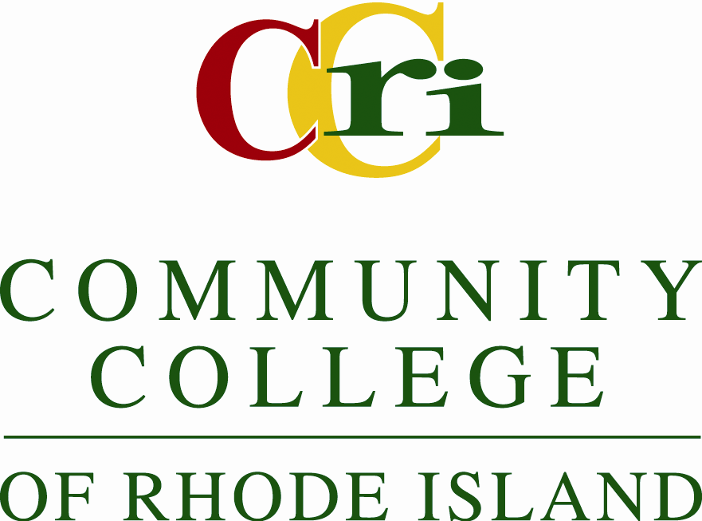

ACADEMIC PROGRAM REVIEW PROTOCOL
- The program coordinator/department chair is notified by the Vice president for Academic Affairs that the program is scheduled for an academic review.
- The program coordinator/department chair notifies the program faculty about the program review. Program Faculty meet to establish a Program Review Committee and identify a committee chair.
- The Program Review chair schedules a meeting with the Vice president for Academic Affairs to establish a time frame for the review process.
- The Academic Program Review Committee (APRC) designates a mentoring team for the program undergoing review.
- The Review Committee chair schedules a preliminary meeting with the APRC mentoring team.
- The program review is completed with input from as many program faculty as possible.
- All program faculty review the completed document (required, see form APR.1) and are given the opportunity to comment on the content.
- The completed review and any faculty comments are sent to the Vice president for Academic Affairs who is responsible for forwarding the material to the APRC.
- If it is anticipated that the review cannot be completed as scheduled, the Program Review chair must notify the Vice president for Academic Affairs to request an extension at least one month before the due date.
- The Program Review Committee and the APR schedule a date for presentation and discussion of the review. This meeting is conducted as a faculty forum. All program faculty are encouraged to attend.
- After the meeting, the APRC meets to summarize the conversation, analyze concerns, strength, weaknesses, and needs, and make recommendations.
- The APRC composes a summary report and submits it to the Vice president for Academic Affairs who in turn, reviews and the returns it to the APRC and the Program Review Committee with comments, if any.
- The Program Review Committee has the opportunity to respond in writing to the summary report and comments of the APRC and the Vice president for Academic Affairs.
- The review is archived in each of the 4 CCRI Learning Resource Centers.
15. At the end of the academic year all reviewed programs are invited en masse to participate in a general discussion of the review process.

