No Show processing update – Please forward to ALL faculty.
The No Show process is now called the Verification of Attendance process;

All faculty (including those who have every student attend) should log into their MyCCRI account to verify attendance.
Click on the For Faculty tab:
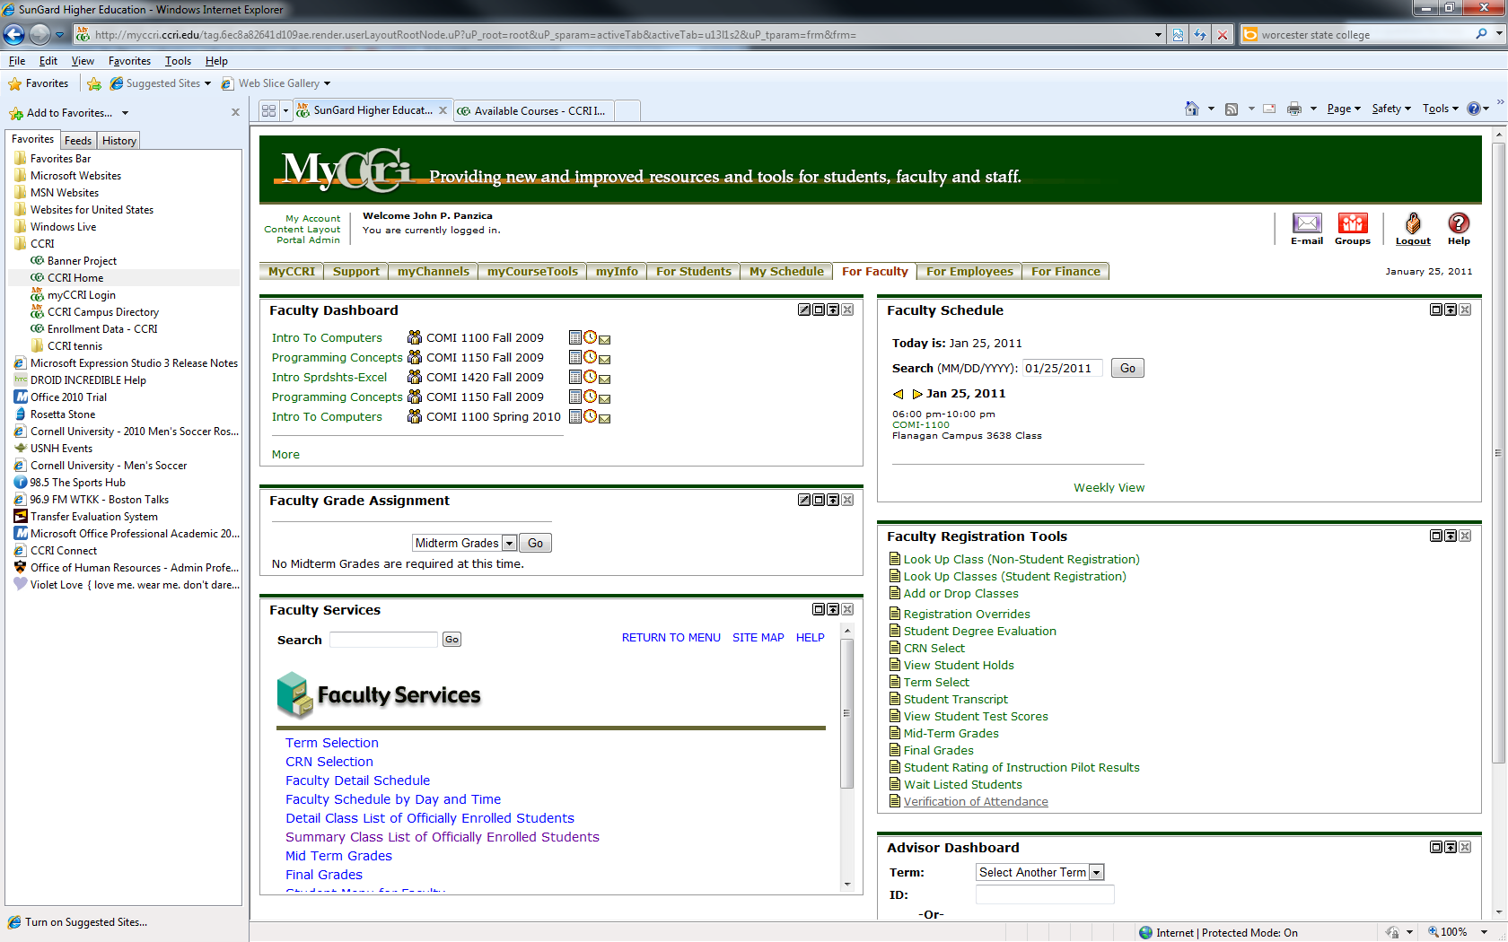

In the Faculty Registration Tools Channel, there is a new link: the Verification of Attendance link.

Click the link:

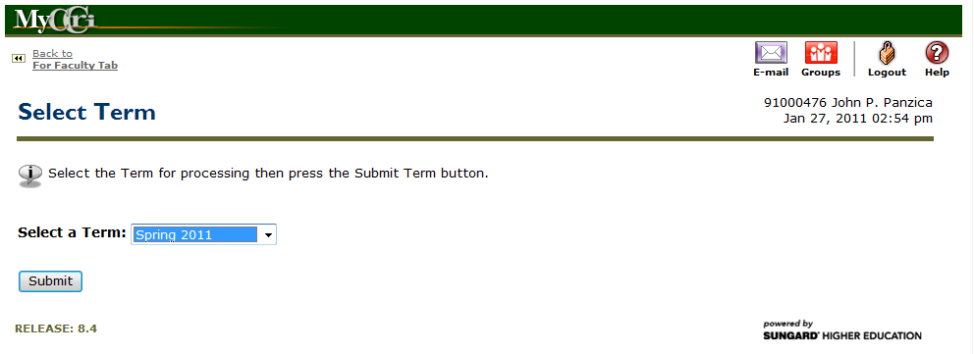
Select the Term from the drop-down list and click the Submit button:
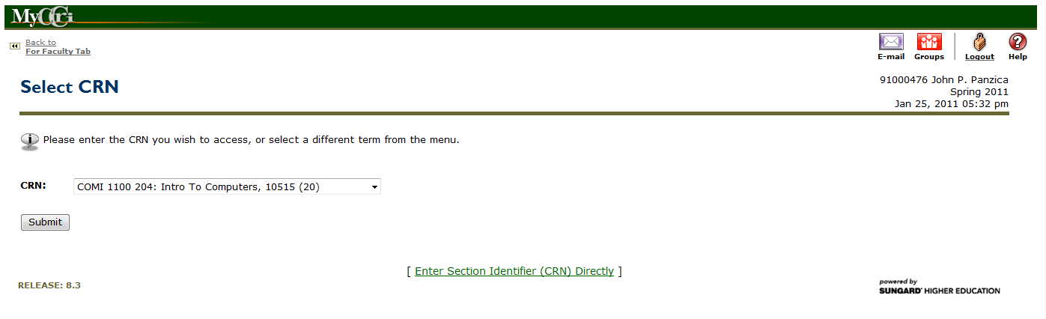
Select the CRN (for the course) from the drop-down list and click the Submit button.
The Verification of Attendance screen displays:
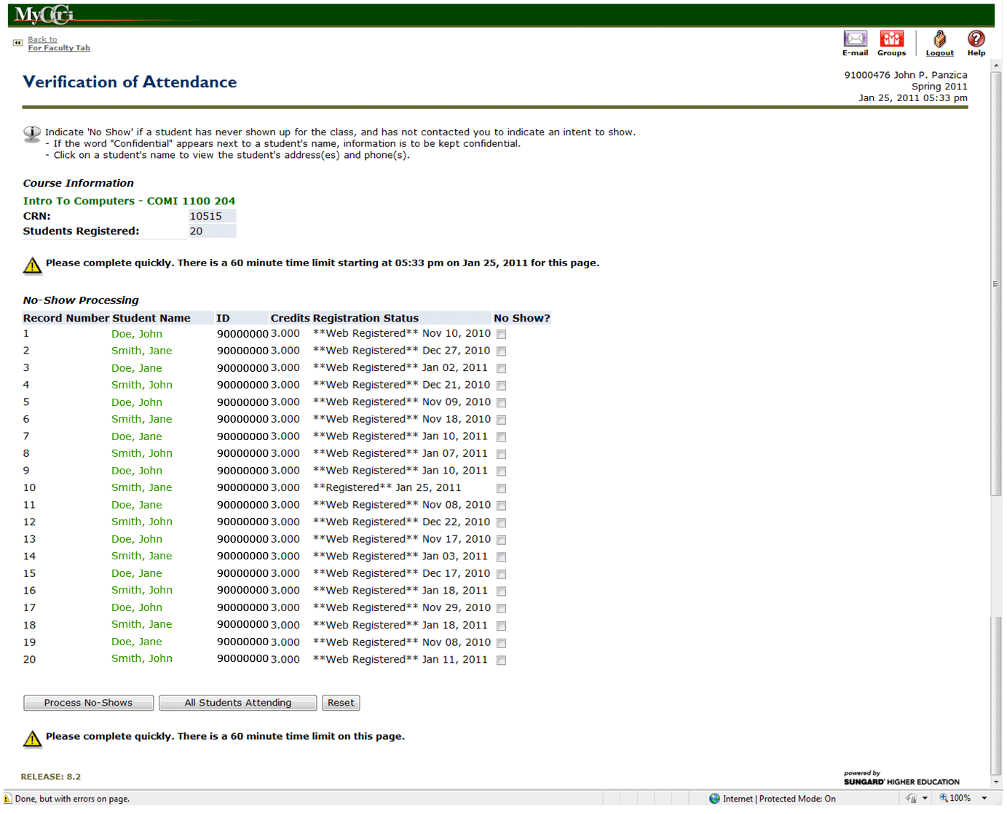

Enter checkmarks for those students that never shown the class, and has not contacted you to indicate an intent to show.
Click the Process No-Shows button.

If all of your students attended at least one class during the first week, click the All Students Attending button.

Please note:
If you click even a single checkbox and try to click the All Students Attending button it will not work.
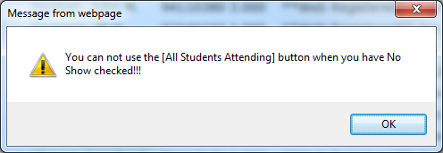

If you don’t click any boxes and press the Process No Shows button you will get a message immediately above the list. It will say that You have made no changes to the No Show Processing. No changes were made to the database.

Please submit all no shows no later than the end of the drop period for the course.
- For full-term classes, the drop period ends as of the 14th calendar day of the term
- For modular courses, the drop period ends as of the 7th calendar day after the start of the course

