Lab: Velocity and Acceleration Using the Airtrack

TILT: Transparency in Learning and Teaching Higher Ed
- provides a guide for developing, explaining, and discussing assignments
- making these aspects of assignment explicitly clear to students enhances students’ learning

Due Dates:
- Perform Trial 1 experiment and tasks during lab period: September 14
TILT: added due dates
- Perform Trial 2 experiment and tasks during lab period: September 21
TILT: split assignment into smaller sections

Purpose:
The purpose of this assignment is help you develop laboratory skills, improve your graphical analysis abilities, and better understand the kinematic principles of Physics.
TILT: skills were included using Bloom’s taxonomy of educational objectives

- Skills:
The purpose of this assignment is to help you practice the following skills that are essential to your success in this course and professional life beyond school:
- measure and record data in a laboratory setting
- explain the graphs and equations and relate them to topics learned in class
- evaluate assumptions made during the experiment
- create graphs and model data into equation form

- Knowledge:
This assignment will also help you become familiar with the following important content knowledge required for successful completion in a Physics course:
- displacement
- velocity
TILT: specific knowledge this assignment reinforces is explicitly stated for students

- acceleration

Theory:
The objective of this experiment is to measure the one-dimensional displacement of a moving object as a function of time in a frictionless environment in order to calculate its velocity and acceleration. The Airtrack is used to create a nearly frictionless surface to study linear motion. Two trials are performed. Trial 1 will investigate constant-velocity motion. When the velocity of an object is constant, its acceleration is equal to zero. During Trial 2, the moving object will accelerate down the declined surface of the air track.

Recall, average velocity ${\overline{v}}_{x}$ is a function of displacement $∆x$ and time t. Displacement is defined as the change in position:
$∆x=x-x_{0}$ (Eq. 1)
Where: $x$ = final position at some later time t
$x_{0}$ = initial position at the initial time t₀

Average velocity is displacement per time taken:

${\overline{v}}_{x}=\frac{∆x}{∆t}=\frac{x-x_{0}}{t-t_{0}}$ (Eq. 2)

Where: $∆t$ = time interval between t₀ and t

When an object is speeding up or slowing down, it is accelerating. Average acceleration ${\overline{a}}_{x}$ is calculated as the change in velocity per time taken:

${\overline{a}}_{x}=\frac{∆v_{x}}{∆t}=\frac{v_{x}-v_{0x}}{t-t_{0}}$ (Eq. 3)

Where: $v_{x}$ = final velocity at some later time t
$v_{0x}$ = initial velocity at the initial time t₀

TILT: more detailed instructions defined for students

Experiment:
Trial 1: To start, secure a piece of electrically sensitive paper along the length of the Airtrack. As the glider moves along the track, it creates dots on this paper at regular time intervals using a spark generator, thus recording its position at known times.
For Trial 1, be sure that the Airtrack is well leveled and horizontal. This will ensure zero acceleration and the glider will travel at a constant velocity. Check the Smart Timer, which is used to measure the actual velocity of the glider. The Smart Timer should read “speed”, “one gate”, and an asterisk should appear at the bottom.
Set the spark generator to create dots with a frequency of 2 Hertz, Hz. This will record the position of the glider every 0.5 seconds. Starting at the left end of the Airtrack, give the glider a slight push. Immediately after this, hold the trigger of the spark generator and continue to hold the trigger as the glider moves along the entire length of the track. Just before the glider reaches the other end, release the trigger. Record the actual velocity from the Smart Timer. This value is used in the percent error calculation.

Actual velocity measured from Smart Timer = __________________________________ cm/s

Carefully remove the electrically sensitive paper from the track and secure it to the lab bench. For Trial 1, the acceleration of the glider is zero and therefore it moves at a constant velocity. The dots on the paper should be equally spaced. When an object moves at a constant velocity, it travels the same distance in each, equal time interval. The time interval between each dot is equal, 0.5 s, and therefore, these dots are equally spaced showing that the glider is moving at a constant velocity.

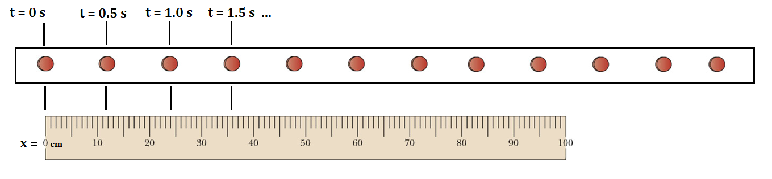

With a meter stick, measure the position in centimeters, cm, of each dot. Be sure that the origin of a meter stick, 0 cm, remains aligned with the first well-defined dot at 0 seconds. Record the position (cm) at each 0.5-second in Table 1.
Table 1: Acceleration = 0
Time (sec) | X, Position (cm)
0.0 s | 0.0
0.5 s
1.0 s
1.5 s
2.0 s
2.5 s
3.0 s
3.5 s
4.0 s
4.5 s
5.0 s

Trial 2: To start, secure a new piece of electrically sensitive paper along the length of the Airtrack. Prop the left end of the Airtrack with the supports provided. Now, the glider will accelerate down the declined surface of the track, speeding up as it does so. Check the Smart Timer, which is used in Trial 2 to measure the actual acceleration of the glider. The Smart Timer should now read “acceleration”, “one gate”, and an asterisk should appear at the bottom.
Set the spark generator to create dots with a frequency of 2 Hertz, Hz. This will again record the position of the glider every 0.5 seconds. Starting at the elevated end of the Airtrack, hold the glider at rest. Hold the trigger of the spark generator and release the glider. Continue to hold the trigger as the glider moves along the entire length of the track. Just before the glider reaches the other end, release the trigger. Record the actual acceleration from the Smart Timer. This value is used in the percent error calculation.

Actual acceleration measure from Smart Timer = __________________________________ cm/s²

Carefully remove the electrically sensitive paper from the track and secure it to the lab bench. For Trial 2, the dots are not equally spaced as they were in Trial 1. Instead, the space between each successive dot becomes increasingly larger. As the glider accelerates, it speeds up. It now travels a greater distance in each 0.5-second time interval.

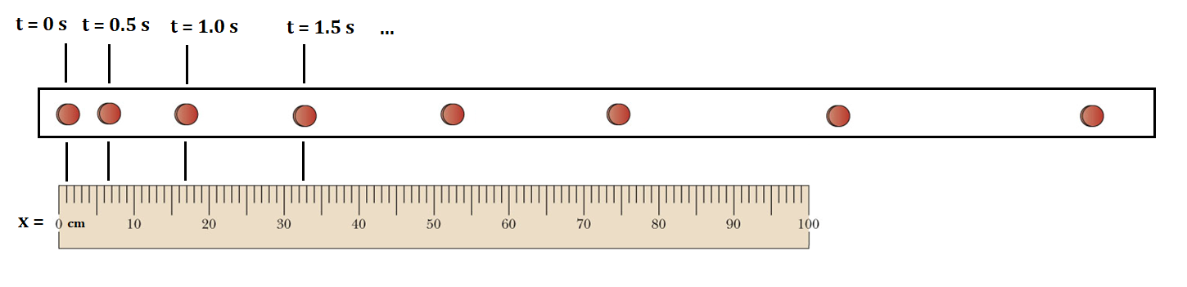
With a meter stick, measure the position in centimeters, cm, of each dot. Be sure that the origin of a meter stick, 0 cm, remains aligned with the first well-defined dot at 0 seconds. Record the position (cm) at each 0.5-second in Table 2. Then, calculate the displacement (cm) and velocity (cm/s) using Equation 1 and Equation 2 respectively. Record values in Table 2.

Table 2: Acceleration > 0
Time (sec) | X, Position (cm) | Displacement (cm) | Velocity (cm/s)
0.0 s
0.5 s
1.0 s
1.5 s
2.0 s
2.5 s
3.0 s
3.5 s
4.0 s
4.5 s
5.0 s

TILT
- explicitly define actions students should take
- Bloom’s taxonomy action verbs used when appropriate
- specify mistakes to be avoided

Tasks:
To complete this assignment, you should generate three graphs using Microsoft Excel. Perform the calculations and answer the proposed questions on separate paper.

Graph 1:
- Trial 1
- Plot Time (sec) on the x-axis and Position (cm) on the y-axis
  - Use an XY-scatter plot that only includes the points, no lines. We will add a trendline later.
Backwards Design
- Identify desired results
  - learning outcomes 3B.1 – 3B.6
- Determine acceptable evidence
  - created rubric
- Plan learning experience
  - improved assignment
  - added specific questions
  - Label both axes and include units
  - Title the graph
- Insert a linear trendline
- Insert the equation of the graph
- Determine the slope of the line

- Slope = _______________________
- What are the slope units? Include them in the above value.
- What physical quantity does the slope represent?
- Is the slope of this graph constant?
- Since the slope of a Displacement vs. Time graph is the velocity, what can we conclude about the velocity of the glider in Trial 1?
Backwards Design: questions added to assess specific student learning objective

- Calculate % Error, show all work including units
  - Experimental velocity = value you determined from slope
  - Actual velocity = value measured from Smart Timer
  - We can state that the experimental results confirm those from theoretical or measurable means when the percent error is less than 10%. Using this formula, a negative percent error indicates the experimental result is less than the actual value.

$$Percent error= \left(\frac{Experimental-Actual}{Actual}\right)×100$$
Graph 2:
- Trial 2
- Plot Time (sec) on the x-axis and Position (cm) on the y-axis
  - Use an XY-scatter plot that only includes the points, no lines. We will add a trendline later.
  - Label both axes and include units
  - Title the graph
- Insert a polynomial trendline with an order of “2”. This is also referred to as a quadratic equation.
- Insert the equation of the graph. Transcribe the equation of the graph onto your separate work paper.

- Compare your equation to the quadratic equation of displacement as a function of time:
$$x=x_{0}+v_{o} t+ \frac{1}{2}a t^{2}$$
- Where:
$x_{0}$ = initial position
$v_{o}$ = initial velocity
$a$ = acceleration

- From your graph equation, what are the following values? Include appropriate units.

- $x_{0}$ = __________________________________

- $v_{o}$ = __________________________________

- $a$ = __________________________________

- Do these values agree with those from the experiment? Explain.

- Is the slope of this graph constant?
- Since the slope of a Displacement vs. Time graph is the velocity, what can we conclude about the velocity of the glider in Trial 2?
Graph 3:
- Trial 2
- Plot Time (sec) on the x-axis and velocity (cm) on the y-axis
  - Use an XY-scatter plot that only includes the points, no lines. We will add a trendline later.
  - Label both axes and include units
  - Title the graph
- Insert a linear trendline
- Insert the equation of the graph.
- Determine the slope of the line

- Slope = _______________________
- What are the slope units? Include them in the above value.
- What physical quantity does the slope represent?
- Is the slope of this graph constant?
- Since the slope of a velocity vs. time graph is the acceleration, what can we conclude about the acceleration of the glider in Trial 2?

- Calculate % Error, show all work including units
  - Experimental acceleration = value you determined from slope
  - Actual acceleration = value measured from Smart Timer

$$Percent error= \left(\frac{Experimental-Actual}{Actual}\right)×100$$

- Explain several possible sources for error.
- Explain how the skills and knowledge developed in this assignment could be applied in the real world outside of the laboratory or school setting.

TILT: reflection added - how do the skills and knowledge developed in this assignment apply to real world settings?

Criteria for Success:

- When completed, you will hand in the following:
- three printed graphs
TILT
- added criteria for success
- specifically defined finished product
- answers to all the proposed questions
  - typed, double-spaced
  - use complete sentences
- all calculations required
  - show all work with units

- Your work will be graded using the attached rubric

Rubric created and provided for students allows for full transparency for grading

